REPUBLIC OF ARMENIA
MINISTRY OF LABOR AND SOCIAL AFFAIRS
SOCIAL PROTECTION ADMINISTRATION II PROJECT
LOAN N 5398-AM

ENVIRONMENTAL AND SOCIAL MANAGEMENT PLAN
RENOVATION OF PREMISES
FOR SEVAN COMPLEX SOCIAL SERVICES TERRITORIAL CENTER

AUTHORS:
Engineer/Environmental specialist – T. Tadevosyan
ME and Social Safeguards specialist – N. Mkrtchyan

NOVEMBER 2018

PART A: General Project and Site Information
INSTITUTIONAL & ADMINISTRATIVE
Country | Republic of Armenia
Project title | Social Protection Administration II Project (SPAP II), Renovation of Premises for Sevan Complex Social Services Territorial Center (CSSTC) in Gegharkunik Marz
Scope of site-specific activity | The following activities will be implemented at the construction site of Sevan CSSTC: demolition works (clearing interior of damaged finishing), arrangement of internal engineering networks (power, gas, water and wastewater) and connections to the municipal utility systems, installing internal and external doors and windows, construction of new partition walls, finishing of floors, internal walls and ceilings, mounting of internal infrastructure, construction of wheelchair ramps and partial improvement of yard area.  An area of 647 sq. m from the first floor of the building has been allocated for the establishment of the CSSTC.
Institutional arrangements (WB) | Task Team Leaders:  Ivan Drabek, Marina Petrovic |  | Safeguards Specialists:  Darejan Kapanadze, Environment  Vera Dugandzic, Social
Implementation arrangements (RoA) | Implementing entity:  Ministry of Labor and Social Affairs (MLSA) | Works supervisor:  MLSA:  Tovmas Tadevosyan, Environment  Nvard Mkrtchyan,  Social |  | Works contractor:  (TBD)
SITE DESCRIPTION
Name of institution whose premises are to be rehabilitated | Sevan CSSTC in Gegharkunik marz
Address and site location of institution whose premises are to be rehabilitated | Nairyan str.164, Administrative bld., Sevan community, Gegharkunik marz, Republic of Armenia
Who uses the land (formal/informal)? | The land is owned by Sevan community.  The document confirming the real estate acquisition right is the Certificate of State Registration of the Rights over Real Estate N 05-0048, issued 26.02.2018 provided on the basis of the Contract on perpetual right of free use of the real estate dated 21.02.2018 (Appendix 2).  Premises to be used by Sevan CSSTC are located in Sevan City Hall administrative building. Part of the building is used by Sevan State Social Security Service (SSSS) territorial department, while the other part is currently not in use. Idle part of the building is the one allocated for renovation under SPAP II and the use by Sevan CSSTC. Thus, the renovation works will not entail any physical displacement (relocation or loss of shelter) or economic displacement (loss of assets or access to assets that leads to loss of income sources or means of livelihood).
Description of physical and natural environment around the site | The building is in the central part of Sevan community. There are residential and other buildings nearby. The road leading to the Center is asphalted, there are no trees and bushes hindering the construction works.  The external electricity, natural gas, water supply and wastewater disposal of the CSSTC are currently in place and will remain unchanged; and the internal communications and infrastructures, electricity wires and water pipes, will be fully replaced. The premises are State property and cannot be used for private reasons or profit.  The civil works will not interfere with everyday life of nearby residents or the activity of the public transportation.  The renovation works will take 240 days from the start of works.  The project’s Social and Environmental Specialists have visited and pre-screened the site.
Locations and distance for material sourcing, especially aggregates, water, stones? | The necessary aggregates and other construction materials are available from nearby vendors or wholesale trade centers.  Water required for construction works is available inside the building, supplied by “Veolia Jur” CJSC.  There is sufficient space for parking construction vehicles and machinery on the territory adjacent to CSSTC and to establish a temporary warehouse for the building materials and construction waste.
LEGISLATION
National & local legislation & permits that apply to project activity | The following Armenian legislation defines a legal framework applicable to project activities:  - Law on Atmospheric Air Protection of RoA (1994).  The purpose of Law on Atmospheric Air Protection is to define main principles of the RoA, directed to provision of purity of atmospheric air and improvement of air quality, prevention and mitigation of the chemical, physical, biological and other impacts on air quality and regulation of public relation, as well as the principle of setting standards of emission limits on atmospheric air pollutants and on permissible physical harmful influences.  According to this law contractor shall undertake repairs activities as well as transportation and temporary storage of wastes the way to minimize dust and other emissions to the air.  - RoA Law on Waste (2004).  The law provides the legal and economic basis for collection, transportation, disposal, treatment, re-use of wastes as well as prevention of negative impacts of waste on natural resources, human life and health. The law defines the roles and responsibilities of the state authorized bodies as well as of waste generator organizations in waste management operations.  According to this law, the waste generated during renovation of the building should be recycled as appropriate or disposed of in designated locations. According this law, the contractor shall absorb costs of safe storage, transportation and disposal of the waste.  - RoA Law on Environmental Impact Assessment and Expertise (2014)  The law defines types of activities which are subject to environmental impact assessment and ecological expertize.  According to this law, works for the rehabilitation of premises for the CSSTC are not subject to the ecological expertize.  - Land Code of the Republic of Armenia (2001)  Taking into account the nature protection, economic and social significance of the land, the Land Code defines the basic directions of State regulatory system concerning land relations, development of various organizational and legal forms of land economy, fertility of land, land use efficiency raise, protection and improvement of an environment – favorable for human vitality and health, the legal framework concerning the protection of the rights on land, as well as regulation of resettlement and evacuation problems.  Rehabilitation of Sevan CSSTC will not cause resettlement neither as defined by this law nor as by OP/BP 4.12 of the World Bank.  - Water Code of the Republic of Armenia (2002)  Water Use: Removing water from or otherwise reducing water in a water resource; storing water; impeding or diverting the flow of a water resource; polluting a water resource; discharging wastewater into a water resource; disposing or storing hazardous substance in a manner that may detrimentally impact a water resource; and, altering the beds, banks, course or characteristics of a water resource.  Water Use Permit: A document, which includes the rights and responsibilities of a person related to the extraction of water from and  discharge of water into a water resource.  The Design Company shall secure a water use permit for any required type of water use, except cases determined by this Code.  - RoA Law on Nature Protection and Nature Utilization (1998)  Nature protection payment – compulsory payment that generates funds for implementation of environmental programs which, under this law, is paid to the State budget or, in cases specified by law, to the community budgets.  The Construction Company that implements activities specified in this law is responsible for nature protection and nature utilization payments.  - RoA Law on Urban Development (1998).  The law defines types of activities which are subject to construction permitting.  According to this law, rehabilitation works (except for construction, reconstruction) planned at institution do not require obtaining of the construction permit.
PUBLIC CONSULTATION
When / where the public consultation process will take /took place | Present draft ESMP will be disclosed through the webpage of MLSA (www.mlsa.am) in Armenian and English languages upon clearance by the World Bank. Public consultation on the draft ESMP will be announced through the media accessible for local stakeholders and held after disclosure of the draft ESMP.  Brief information on the planned works, and contact information of contractor for addressing questions and grievance will be placed at the work site and/or in its immediate surroundings.
ATTACHMENTS
Attachment 1: Site plan and photo documentation of premises before repair
Attachment 2: Building ownership certificate
Attachment 3: Conclusion of the seismic resistance test
Attachment 4: Minutes of public consultation meeting and announcement-invitation (to be provided)
Attachment 5: Agreement for waste disposal

PART B: safeguards information
ENVIRONMENTAL /SOCIAL SCREENING
Will the site activity include/involve any of the following? | Activity/Issue | Status | Triggered Actions
 | - Building rehabilitation | [] Yes [ ] No | See Section A below
 | - New construction | [ ] Yes [] No | See Section A below
 | - Individual wastewater treatment system | [ ] Yes [] No | See Section B below
 | - Historic building(s) and districts | [ ] Yes [ ] No | See Section C below
 | - Acquisition of land | [ ] Yes [] No | See Section D below
 | - Hazardous or toxic materials | [ ] Yes [] No | See Section E below
 | - Impacts on forests and/or protected areas | [ ] Yes [] No | See Section F below
 | - Handling / management of medical waste | [ ] Yes [] No | See Section G below
 | - Traffic and Pedestrian Safety | [ ] Yes [] No | See Section H below
PART C: Mitigation measures
ACTIVITY | PARAMETER | MITIGATION MEASURES CHECKLIST
General Conditions | Notification and Worker Safety | - The local construction and environment inspectorates and communities have been notified of upcoming activities  - The public has been notified of the works through appropriate notification in the media and/or at publicly accessible sites (including the site of the works)  - All legally required permits have been acquired for construction and/or rehabilitation  - The Contractor formally agrees that all work will be carried out in a safe and disciplined manner designed to minimize impacts on neighboring residents and environment.  - Workers’ PPE will comply with international good practice (always hardhats, as needed masks and safety glasses, harnesses and safety boots)  - Appropriate signposting of the sites will inform workers of key rules and regulations to follow.
A. General Rehabilitation and /or Construction Activities | Air Quality | - Demolition debris shall be kept in controlled area and sprayed with water mist to reduce debris dust  - During pneumatic drilling/wall destruction, dust shall be suppressed by water spraying and/or installing dust screen enclosures at site  - The surrounding environment (sidewalks, roads) shall be kept free of debris to minimize dust  - There will be no open burning of construction / waste material at the site  - There will be no excessive idling of construction vehicles at sites
 | Noise | - Construction noise will be limited to restricted times agreed to in the permit. The civil works will cause some noise mostly in defined working hours, however the Contractor shall maximally reduce inconvenience caused to the nearby residents  - During operations the engine covers of generators, air compressors and other powered mechanical equipment shall be closed, and equipment placed as far away from residential areas as possible
 | Water Quality | - The site will establish appropriate erosion and sediment control measures such as e.g. hay bales and / or silt fences to prevent sediment from moving off site and causing excessive turbidity in nearby streams and rivers.
 | Waste management | - Waste collection and disposal pathways and sites will be identified for all major waste types expected from demolition and construction activities.  - Mineral construction and demolition wastes will be separated from general refuse, organic, liquid and chemical wastes by on-site sorting and stored in appropriate containers.  - Construction waste will be collected and disposed properly by licensed collectors  - The records of waste disposal will be maintained as proof for proper management as designed.  - Whenever feasible the contractor will reuse and recycle appropriate and viable materials (except asbestos)
H. Traffic and Pedestrian Safety | Direct or indirect hazards to public traffic and pedestrians by construction  activities | In compliance with national regulations the contractor will insure that the construction site is properly secured, and construction related traffic regulated. This includes but is not limited to  - Signposting, warning signs, barriers and traffic diversions: site will be clearly visible, and the public warned of all potential hazards  - Traffic management system and staff training, especially for site access and near-site heavy traffic. Provision of safe passages and crossings for pedestrians where construction traffic interferes.  - Adjustment of working hours to local traffic patterns, e.g. avoiding major transport activities during rush hours or times of livestock movement  - Active traffic management by trained and visible staff at the site, if required for safe and convenient passage for the public.  - Ensuring safe and continuous access to office facilities, shops and residences during renovation activities, if buildings stay open for public.

PART D: Monitoring Plan
Activity | What  (Is the parameter to be monitored?) | Where  (Is the parameter to be monitored?) | How  (Is the parameter to be monitored?) | When  (Define the frequency / or continuous?) | Why  (Is the parameter being monitored?) | Who  (Is responsible for monitoring?)
CONSTRUCTION PHASE
Provision of construction materials | Purchase of construction materials from the registered providers | Provider’s office or warehouse | Verification of labels of the materials and/or certificates | During conclusion of supply contracts | Ensure reliability of construction materials and their safety for human health | MLSA
Generation of construction waste | - Temporary storage of construction waste in especially allocated areas;  - Timely disposal of wastes to the formally designated locations | Work site | Inspection | Periodically during reconstruction and upon its completion | - Prevent pollution of territory  - avoid accidents at construction site due to scattered fragments of construction materials and debris  - retain esthetic appearance of the reconstruction site and other floors | MLSA
Transportation of construction materials and waste | - Technical condition of vehicles and machinery;  - Confinement and protection of truck loads with lining;  - Respect of the established hours and routes of transportation | - Construction site  - Routes of transportation of construction materials and wastes | Inspection of roads adjacent to the construction object in the direction of the movement route | Selective inspections during work hours | - Limit pollution of soil and air from emissions;  - Limit nuisance to local communities from noise and vibration;  - Minimize traffic disruption. | Traffic Police
Workers’ health and safety | - Provision of constructors with working clothes and PPE;  - Strict compliance with the rules of construction equipment operation and usage of PPE;  - Presence of fire extinguishing and medical aid kits at work site | Work site | Inspection | Entire period of works | Reduce probability of traumas and accidents | MLSA
Traffic and road safety | - Presence of traffic regulation and warning signs as needed;  - Construction site demarcated/fenced, and all construction activities confined to the site;  - No construction materials and waste piled up or scattered outside the construction site | Adjacent area to the construction site | Inspection | Entire period of construction works | Prevent the violation of interests of the passengers and/or pedestrians because of the construction works | MLSA
Site reinstatement | Land plot around the reconstructed premises cleared of any residual waste and reinstated | Construction site | inspection | Final stage of works | Ensure complete close-down of the construction site with no residual trash left behind | MLSA
Public information and grievance redress | Information board installed at the work site carrying:  - the name of works provider (contractor), works commissioner (MLSA), and works financing Project (SPAP);  - contact information / hotline in MLSA for local communities to refer complains on the nuisance caused by construction works | Field office of the contractor and construction site | Inspection of documents | Before and during the construction works | Communicate with the residents or employees as well as other stakeholders of the area adjacent to the construction site and register the complaints | MLSA
OPERATION PHASE
Operational waste management | - Organized collection of household waste generated during office operation inside CSSTC;  - Arrangements in place and operational for removal of household waste from CSSTC | CSSTC space | Inspection of office area | Entire period of office operation | Ensure sanitary safety and favorable conditions for CSSTC staff | CSSTC administration
Maintenance of internal communication systems | Electric wiring and water/waste water pipes maintained in good operation condition | CSSTC space | Inspection of office area | Entire period of office operation | Exclude risks of electric shocks, short circuits, and leakage of pipes | CSSTC administration
Improved space (premises) | Exterior area of the building kept clean and groomed | Premises of the CSSTC | Inspection | Entire period of works implementation | Ensure favorable social impact of the improved premises on the beneficiaries attending the center. | CSSTC administration

Attachment 1. Site plan and
photo documentation of premises before repair

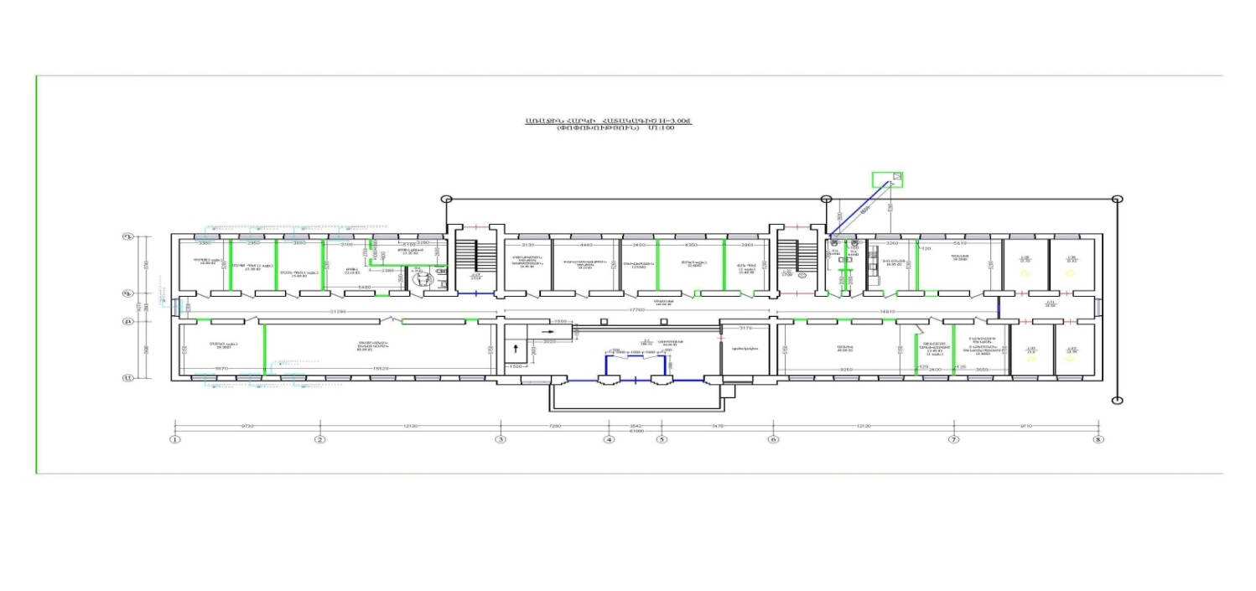
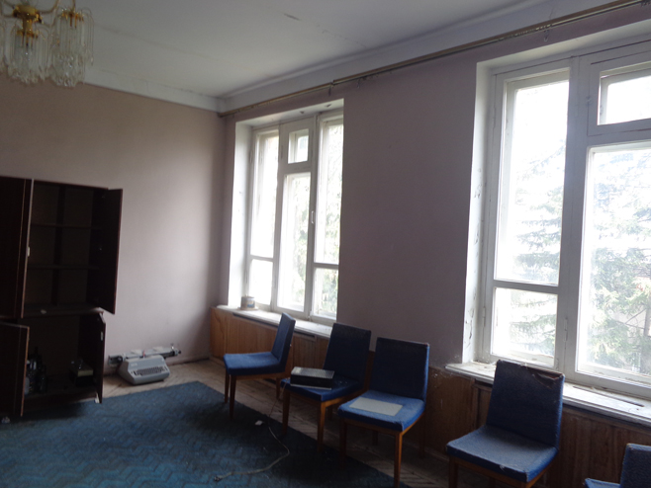

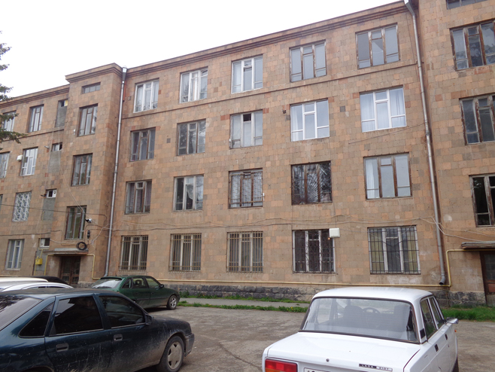

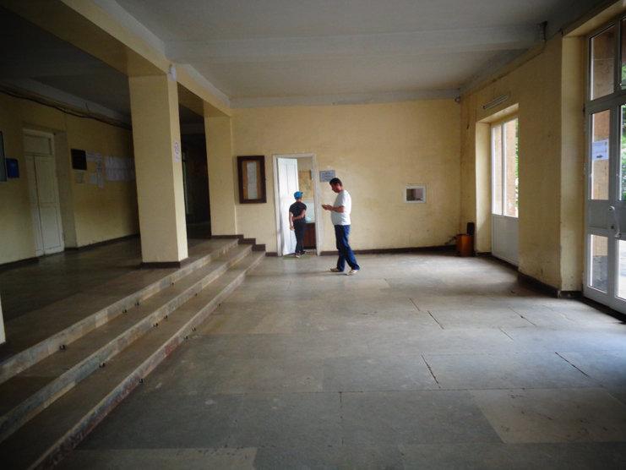
Attachment 2
Building Ownership Certificate

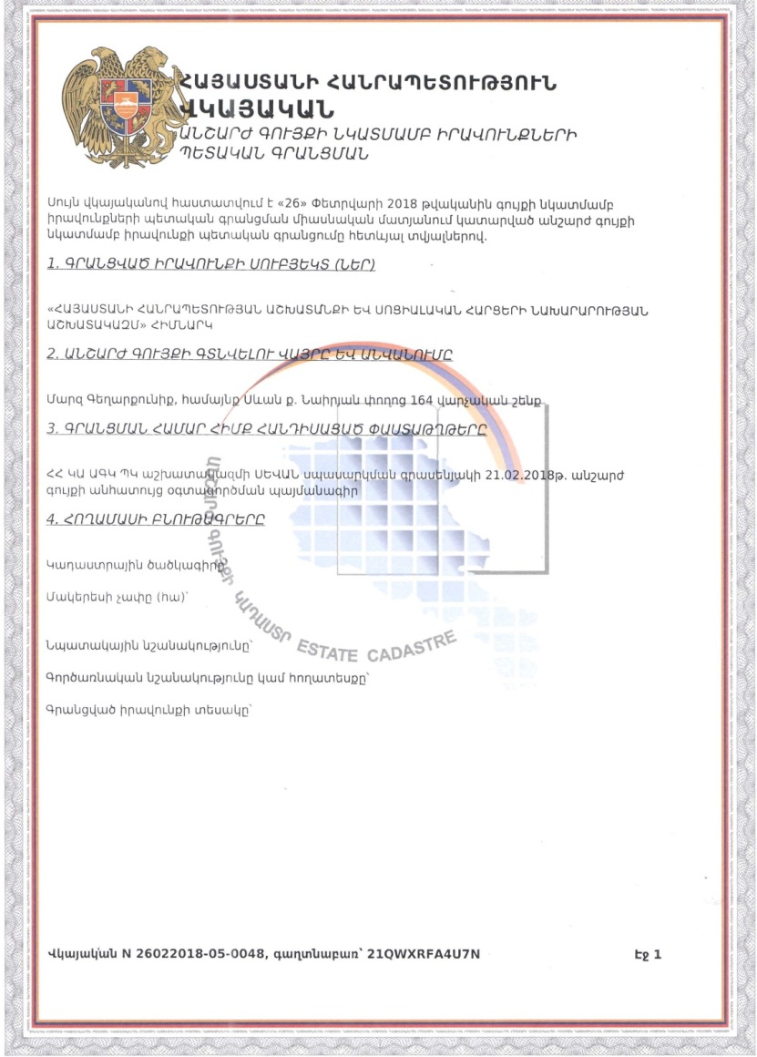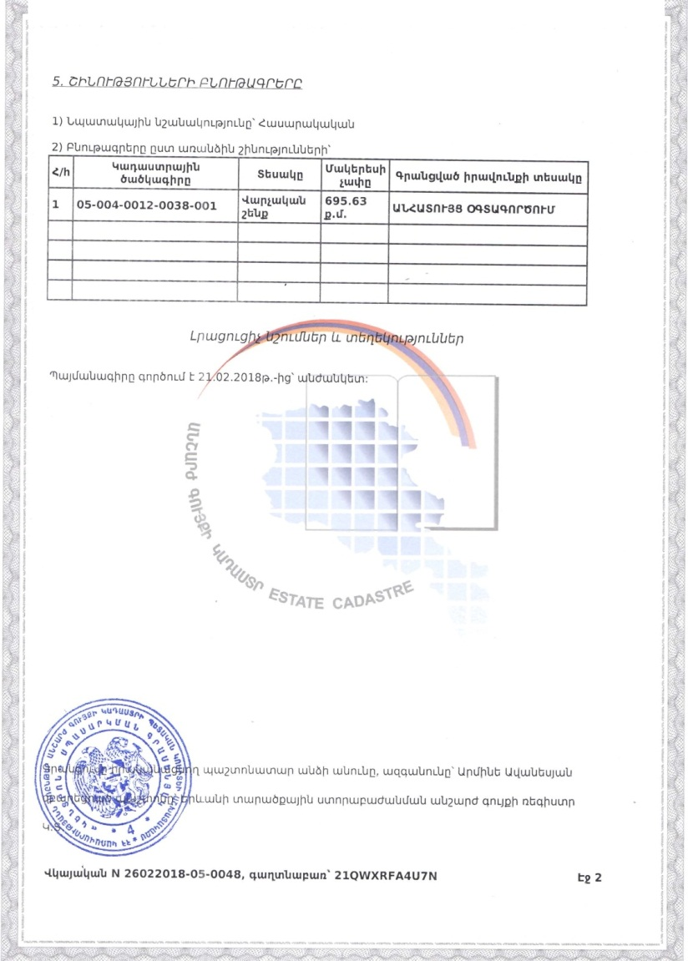

(Non-official translation)
Republic of Armenia
Certificate of State Registration of the Rights over
Real Estate
This Certificate confirms the state registration of the rights over real estate in the integrated registry of state registration of rights over real estate on Feb. 26, 2018 by the following details:
1. Entity(s) of registered right
Ministry of Labor and Social Affairs of the Republic of Armenia
2. The place and name of the real estate
Nairyan str. 164, Administrative building, Sevan community, Gegharkunik marz
3. Documents on which the registration is based:
Contract (21/02/2018) on perpetual right of free use of real estate
4. Land characteristics
Cadaster Code
Surface
Target use
Operational use
Type of registered right

5. Building characteristics
1) Target use – public
2) Characteristics of the separate buildings;

N | Cadaster Code | Type | Surface | Type of registered right
1 | 05-004-0012-0038-001 | Administrative Building | 695.63 sq. m | free use
2
3

Additional Notes and Information
The contract entered into force on 21.02.2018 and is valid for an indefinite period.
Registering official – Armine Avanesyan
Position – Real estate register of Gegharkunik Marz subdivision of the State Committee of the Real Estate Cadaster adjunct to the RoA Government.

Certificate number- 26022018-05-0048, password – 21QWXRFA4U7N

Attachment 3.
Conclusion of the Seismic Resistance Test
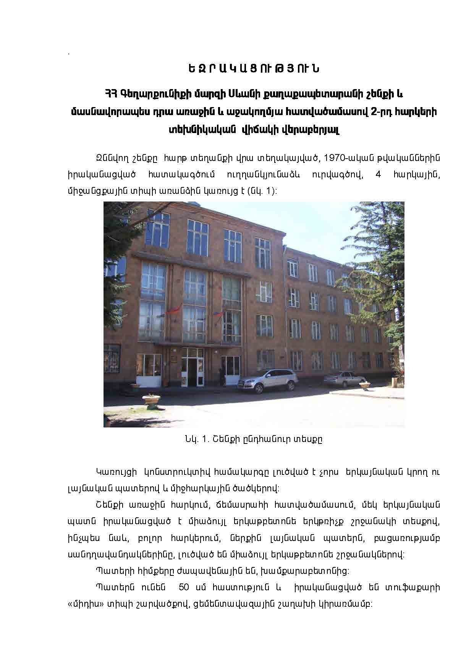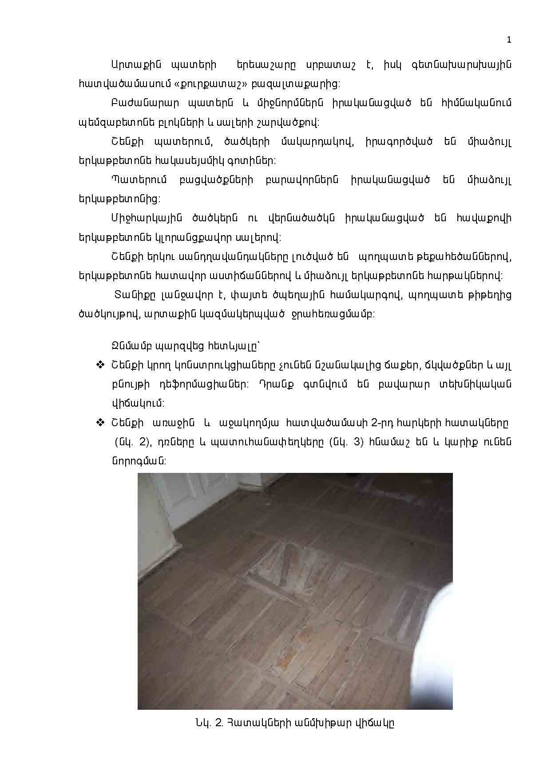

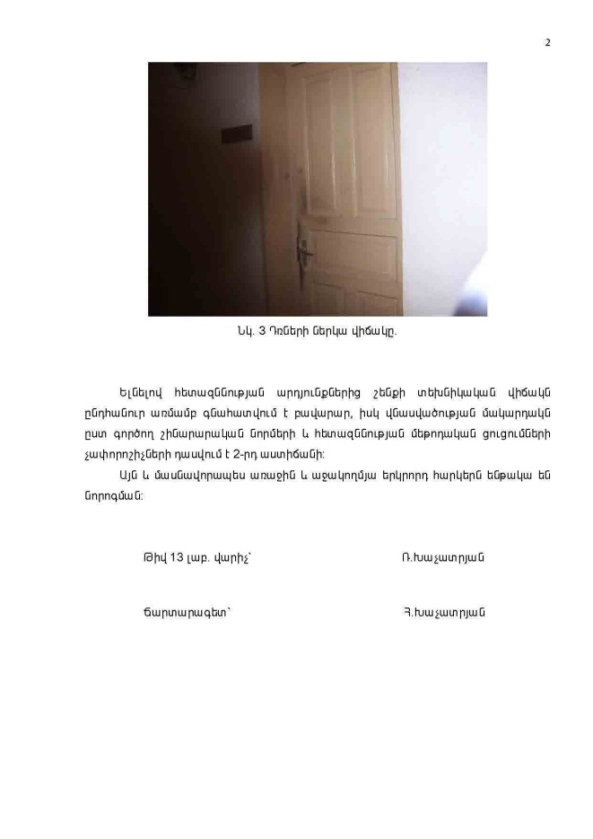
Summary-Excerpt from the

Conclusion on the Technical State of the Complex Social Services Territorial Center Located at Nairyan str. 164, Sevan community, Gegharkunik Marz, Republic of Armenia

The examination was implemented based upon the order of T. Gapoyan – Director of “Tiv 28 SHMSH” OJSC design company.

Visual examination revealed:

Based on the examination of the building the overall technical state is evaluated as satisfactory.
The bearing structures of the building do not have significant defects, fractures or deformations. They are in sufficient shape. The following measures need to be taken to ensure the proper functioning of the building.

- General renovation works, replacement of floors, old doors and windows with new ones.
- Replacement of internal utility infrastructure (gas, water, sewage pipelines, electricity, ventilation system).
- Construction of wheelchair ramp.
- Partial yard improvement.

Implement all the mentioned construction works in compliance with the agreed design and acting construction norms, custom designed and in the manner prescribed.

Head of N 13 Lab R. Khachatryan

Architect H. Khachatryan

Attachment 4.

MINUTES OF THE PUBLIC CONSULTATION MEETING

Attachment 5.
Agreement for Waste Disposal
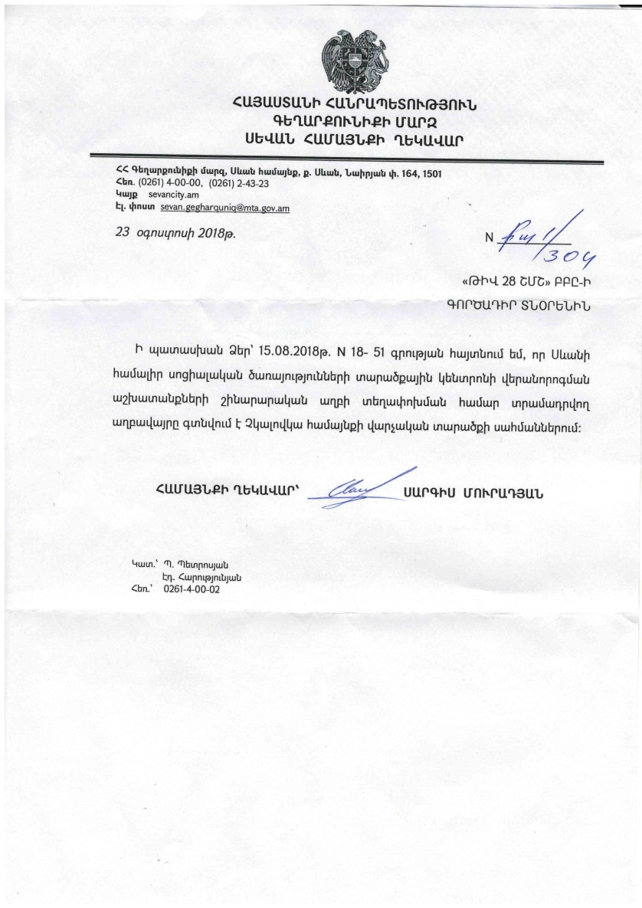
SEVAN COMMUNITY ADMINISTRATION OF
ROA GEGHARKUNIK MARZ

Nairyan str. 164, Sevan, 1501, Gegharkunik marz
Tel.: 0261-4-00-00, 0261-2-43-23
Website: sevancity.am
August 23, 2018

REFERENCE

Responding to the inquiry of “Tiv 28 SHMSH” Design Company, hereby we inform that the construction waste generated at the Sevan CSSTC renovation site will be removed and disposed of at the dump near Chkalovka community.

Head of the Community signature Sargis Muradyan

Land acquisitions includes displacement of people, change of livelihood encroachment on private property this is to land that is purchased/transferred and affects people who are living and/or squatters and/or operate a business (kiosks) on land that is being acquired.
Toxic / hazardous material includes but is not limited to asbestos, toxic paints, noxious solvents, removal of lead paint, etc.

