REPUBLIC OF ARMENIA
MINISTRY OF LABOR AND SOCIAL AFFAIRS
SOCIAL PROTECTION ADMINISTRATION II PROJECT
LOAN N 5398-AM

ENVIRONMENTAL AND SOCIAL MANAGEMENT PLAN
REHABILITATION OF PREMISES
FOR SISIAN COMPLEX SOCIAL SERVICES TERRITORIAL CENTER

AUTHORS:
Environmental Specialist – T. Tadevosyan
ME and Social Safeguards Specialist – N. Mkrtchyan

JANUARY 2021

PART A: General Project and Site Information
INSTITUTIONAL & ADMINISTRATIVE
Country | Republic of Armenia
Project title | Social Protection Administration II Project (SPAP II), Renovation of Premises for Sisian Complex Social Services Territorial Center (CSSTC) in Syunik Marz
Scope of site-specific activity | The following works will be implemented at the construction site: seismic reinforcement, strengthening of door openings, construction of internal and partial rehabilitation of external engineering networks, installation of doors and windows, demolition of internal, non-bearing partition walls, finishing of the walls and ceilings, mounting of internal infrastructure (heating, ventilation, and communication networks), rehabilitation of the drainage system, construction of wheelchair ramps and reconstruction of the staircase. The roof of the building will be renovated under community funds.  Overall an area of 710.44 sq. m from the first and second floors of the 3-story building was allocated for the establishment of the CSSTC.
Institutional arrangements (WB) | Task Team Leaders:  Ivan Drabek,  Natalia Millan, Lucia Solbes Castro |  | Safeguards Specialists:  Hmayak Avagyan, Environment  Vera Dugandzic, Social
Implementation arrangements (RoA) | Implementing entity:  Ministry of Labor and Social Affairs (MLSA) | Works supervisor:  MLSA:  Tovmas Tadevosyan, Environment  Nvard Mkrtchyan,  Social |  | Works contractor:  (TBD)
SITE DESCRIPTION
Name of institution whose premises are to be rehabilitated | Sisian CSSTC in Syunik Marz
Address and site location of institution whose premises are to be rehabilitated | Administrative bld. 41 Sisakan str., Sisian community, Syunik Marz, Republic of Armenia
Who uses the land (formal/informal)? | The land-owner of the construction site is Sisian community.  The document confirming the real estate acquisition right is the Certificate of State Registration of the Rights over Real Estate N 09-0019, issued 15.07.2016 (based on free use contract dated 12.07.2016) (Attachment 2).  The premises are located in the administrative building of the Sisian community, the premises intended for future CSSTC are currently used by Sisian Social Assistance Territorial Agency (SATA) and Territorial Employment Center (TEC). Thus, the renovation works will not entail any physical displacement (relocation or loss of shelter) or economic displacement (loss of assets or access to assets that leads to loss of income sources or means of livelihood). The beneficiaries will have an uninterrupted service delivery during the rehabilitation works, the services will simply be temporarily relocated.
Description of physical and natural environment around the site | The premises allocated for the CSSTC are in the central part of the Sisian community. There are residential houses, stores, and a Culture house nearby. The road leading to the center is asphalted. No trees or bushes are hindering the construction works.  The external electricity and natural gas supply network of the CSSTC are currently in place and will remain unchanged. The water supply and sewage disposal network will partially be rehabilitated. The internal communication network (intranet, phone, seciruty system) and infrastructure - electrical wiring and water pipelines will be fully replaced.  The civil works will not interfere with the everyday life of nearby residents or public transportation, as well as the activity of the nearby stores and the Culture house.  Construction works will take 480 days from start.  The project’s Social and Environmental Specialists have visited and pre-screened the site.
Locations and distance for material sourcing, especially aggregates, water, stones? | The necessary aggregates and other construction materials are available from nearby vendors and wholesale trade centers.  Water required for construction works is available inside the building and is supplied by “Veolia Jur” CJSC.  There is enough space for parking of construction vehicles and machinery on the territory adjacent to the CSSTC building and to establish temporary storage for building materials and construction waste, if necessary.
LEGISLATION
National & local legislation & permits that apply to project activity | The following Armenian legislation defines a legal framework applicable to project activities:  - Law on Atmospheric Air Protection of RoA (1994).  The purpose of Law on Atmospheric Air Protection is to define main principles of the RoA, directed to the provision of purity of atmospheric air and improvement of air quality, prevention and mitigation of the chemical, physical, biological and other impacts on air quality and regulation of public relation, as well as the principle of setting standards of emission limits on atmospheric air pollutants and permissible physical harmful influences.  According to this law, the contractor shall undertake repairs activities as well as transportation and temporary storage of wastes the way to minimize dust and other emissions to the air.  - RoA Law on Waste (2004).  The law provides the legal and economic basis for the collection, transportation, disposal, treatment, re-use of wastes as well as prevention of negative impacts of waste on natural resources, human life and health. The law defines the roles and responsibilities of the state authorized bodies as well as of waste generator organizations in waste management operations.  According to this law, the waste generated during the renovation of the building should be recycled as appropriate or disposed of in designated locations. According to this law, the contractor shall absorb costs of safe storage, transportation, and disposal of the waste.  - RoA Law on Environmental Impact Assessment and Expertise (2014)  The law defines types of activities that are subject to environmental impact assessment and ecological expertise.  According to this law, works for the renovation of premises for the Sisian CSSTC are not subject to ecological expertise.  - Land Code of the Republic of Armenia (2001)  Taking into account the nature protection, economic and social significance of the land, the Land Code defines the basic directions of State regulatory system concerning land relations, development of various organizational and legal forms of land economy, fertility of land, land use efficiency raise, protection and improvement of an environment – favorable for human vitality and health, the legal framework concerning the protection of the rights on land, as well as regulation of resettlement and evacuation problems.  Renovation of Sisian CSSTC will not cause resettlement either as defined by this law nor as by OP/BP 4.12 of the World Bank.  - RoA Law on Urban Development (1998).  The law defines types of activities that are subject to construction permitting.  According to this law, the renovation of the existing premises allocated for Sisian CSSTC requires obtaining the construction permit.
PUBLIC CONSULTATION
When / where the public consultation process will take /took place | Present draft ESMP will be disclosed through the webpage of MLSA (www.mlsa.am) in Armenian and English languages upon clearance by the World Bank. Public consultation on the draft ESMP will be announced through the media accessible for local stakeholders and held after disclosure of the draft ESMP. Due to the quarantine measures in the Republic, the public consultation meeting in the community will most probably be replaced by a virtual consultation by submitting the draft ESMP to the local stakeholders and beneficiaries through emails.  Brief information on the planned works and contact information of the contractor for addressing questions and grievance will be placed at the work site and/or in its immediate surroundings.
ATTACHMENTS
Attachment 1: Site plan and photo documentation of premises
Attachment 2: Premises ownership certificate
Attachment 3: Conclusion on the technical condition of the building
Attachment 4: Records of public consultation meeting (to be provided)
Attachment 5: Waste disposal permission
Attachment 6: Construction Permit

PART B: safeguards information
ENVIRONMENTAL /SOCIAL SCREENING
Will the site activity include/involve any of the following? | Activity/Issue | Status | Triggered Actions
 | - Building rehabilitation | [] Yes [ ] No | If “Yes”, see Section A below
 | - New construction | [] Yes [] No | If “Yes”, see Section A below
 | - Individual wastewater treatment system | [ ] Yes [] No | If “Yes”, see Section B below
 | - Historic building(s) and districts | [ ] Yes [ ] No | If “Yes”, see Section C below
 | - Acquisition of land | [ ] Yes [] No | If “Yes”, see Section D below
 | - Hazardous or toxic materials | [ ] Yes [] No | If “Yes”, see Section E below
 | - Impacts on forests and/or protected areas | [ ] Yes [] No | If “Yes”, see Section F below
 | - Handling / management of medical waste | [ ] Yes [] No | If “Yes”, see Section G below
 | - Traffic and Pedestrian Safety | [ ] Yes [] No | If “Yes”, see Section H below
PART C: Mitigation measures
ACTIVITY | PARAMETER | MITIGATION MEASURES CHECKLIST
General Conditions | Notification and Worker Safety | - The local construction and environment inspectorates and communities have been notified of upcoming activities  - The public has been notified of the works through appropriate notification in the media and/or at publicly accessible sites (including the site of the works)  - All legally required permits have been acquired for construction and/or rehabilitation  - The Contractor formally agrees that all work will be carried out in a safe and disciplined manner designed to minimize impacts on neighboring residents and environment.  - Workers’ PPE will comply with international good practice (always hardhats, as needed masks and safety glasses, harnesses and safety boots)  - Appropriate signposting of the sites will inform workers of key rules and regulations to follow.
A. General Rehabilitation and /or Construction Activities | Air Quality | - Demolition debris shall be kept in controlled area and sprayed with water mist to reduce debris dust  - During pneumatic drilling/wall destruction, dust shall be suppressed by water spraying and/or installing dust screen enclosures at site  - The surrounding environment (sidewalks, roads) shall be kept free of debris to minimize dust  - There will be no open burning of construction / waste material at the site  - There will be no excessive idling of construction vehicles at sites
 | Noise | - Construction noise will be limited to restricted times agreed to in the permit. The civil works will cause some noise mostly in defined working hours, however the Contractor shall maximally reduce inconvenience caused to the nearby residents  - During operations the engine covers of generators, air compressors and other powered mechanical equipment shall be closed, and equipment placed as far away from residential areas as possible
 | Water Quality | - The site will establish appropriate erosion and sediment control measures such as e.g. hay bales and / or silt fences to prevent sediment from moving off site and causing excessive turbidity in nearby streams and rivers.
 | Waste management | - Waste collection and disposal pathways and sites will be identified for all major waste types expected from demolition and construction activities.  - Mineral construction and demolition wastes will be separated from general refuse, organic, liquid and chemical wastes by on-site sorting and stored in appropriate containers.  - Construction waste will be collected and disposed properly by licensed collectors  - The records of waste disposal will be maintained as proof for proper management as designed.  - Whenever feasible the contractor will reuse and recycle appropriate and viable materials (except asbestos)
H. Traffic and Pedestrian Safety | Direct or indirect hazards to public traffic and pedestrians by construction  activities | In compliance with national regulations, the contractor will insure that the construction site is properly secured, and construction-related traffic regulated. This includes but is not limited to  - Signposting, warning signs, barriers and traffic diversions: site will be clearly visible, and the public warned of all potential hazards  - Traffic management system and staff training, especially for site access and near-site heavy traffic. Provision of safe passages and crossings for pedestrians where construction traffic interferes.  - Adjustment of working hours to local traffic patterns, e.g. avoiding major transport activities during rush hours or times of livestock movement  - Active traffic management by trained and visible staff at the site, if required for safe and convenient passage for the public.  - Ensuring safe and continuous access to office facilities, shops and residences during renovation activities, if buildings stay open for public.

PART D: Monitoring Plan
Activity | What  (Is the parameter to be monitored?) | Where  (Is the parameter to be monitored?) | How  (Is the parameter to be monitored?) | When  (Define the frequency / or continuous?) | Why  (Is the parameter being monitored?) | Who  (Is responsible for monitoring?)
CONSTRUCTION PHASE
Provision of construction materials | Purchase of construction materials from the registered providers | Provider’s office or warehouse | Verification of labels of the materials and/or certificates | During the conclusion of supply contracts | Ensure reliability of construction materials and their safety for human health | MLSA  Technical Supervision Company
Generation of construction waste | - Temporary storage of construction waste in especially allocated areas;  - Timely disposal of wastes to the formally designated locations | Work site  Location designated for waste disposal | Inspection | Periodically during reconstruction and upon its completion | - Prevent pollution of territory  - avoid accidents at the construction site due to scattered fragments of construction materials and debris  - retain esthetic appearance of the reconstruction site and other floors | MLSA  Technical Supervision Company
Transportation of construction materials and waste | - Technical condition of vehicles and machinery;  - Confinement and protection of truck loads with lining;  - Respect of the established hours and routes of transportation | - Construction site  - Routes of transportation of construction materials and wastes | Inspection of roads adjacent to the construction object in the direction of the movement route | Selective inspections during work hours | - Limit pollution of soil and air from emissions;  - Limit nuisance to local communities from noise and vibration;  - Minimize traffic disruption. | MLSA  Traffic Police
Maintenance of construction equipment | - Washing of cars and construction equipment outside the construction site or at maximum distance from natural streams;  - Refueling or lubrication of construction equipment outside the construction site or at the predetermined confined area. | Construction site | Inspection of activities | Selective inspections during work hours | - Avoid pollution of water and soil with oil products due to the operation of equipment;  Timely localize and decrease expected damage in case of fire. | MLSA  Technical Supervision Company
Workers’ health and safety | - Provision of constructors with working clothes and PPE;  - Strict compliance with the rules of construction equipment operation and usage of PPE;  - Presence of fire extinguishing and medical aid kits at the work site | Work site | Inspection | Entire period of works | Reduce the probability of traumas and accidents | MLSA  Technical Supervision Company
Traffic and road safety | - Presence of traffic regulation and warning signs as needed;  - Construction site demarcated/fenced, and all construction activities confined to the site;  - No construction materials and waste piled up or scattered outside the construction site | Area adjacent to the construction site | Inspection | Entire period of construction works | Prevent the violation of interests of the passengers and/or pedestrians because of the construction works | MLSA  Traffic Police
Site reinstatement | Land plot around the reconstructed premises cleared of any residual waste and reinstated | Construction site | inspection | Final stage of works | Ensure complete close-down of the construction site with no residual trash left behind | MLSA  Sisian Municipality  Technical Supervision Company
Public information and grievance redress | Information board installed at the work site carrying:  - the name of works provider (contractor), works commissioner (MLSA), and works financing Project (SPAP);  - contact information / hotline in MLSA for local communities to refer complains on the nuisance caused by construction works | Field office of the contractor and construction site | Inspection of documents | Before and during the construction works | Communicate with the residents or employees as well as other stakeholders of the area adjacent to the construction site and register the complaints | MLSA
COVID-19 preparedness in the work site | - Provision of handwash facilities in the work site with adequate supplies of running water, hand soap, alcohol-based hand sanitizer and hand drying devices;  - Worksite entrance procedure and medical checks;  - Regular disinfection of public rooms, equipment, tools, and waste;  - Work practices to reduce or minimize contact between workers;  - Provision of face masks and other relevant PPE to all project workers at the entrance to the project site. | Construction site | Inspection of activities | Total period of works | Reduce the COVID-19 infection risk at worksites | MLSA  Technical supervision company
OPERATION PHASE
Operational waste management | - Organized collection of household waste generated during office operation inside CSSTC;  - Arrangements in place and operational for removal of household waste from CSSTC | CSSTC space | Inspection of office area | Entire period of office operation | Ensure sanitary safety and favorable conditions for CSSTC staff | CSSTC administration
Maintenance of internal communication systems | Electric wiring and water/sewage pipes maintained in good operating condition | CSSTC space | Inspection of office area | Entire period of office operation | Exclude risks of electric shocks, short circuits, and leakage of pipes | CSSTC administration
Improved space (premises) | Exterior area of the building kept clean and groomed | Premises of the CSSTC | Visual Inspection | Entire period of works implementation | Ensure favorable social impact of the improved premises on the beneficiaries attending the center. | CSSTC administration

Attachment 1. Site plan and
photo documentation of premises before repair

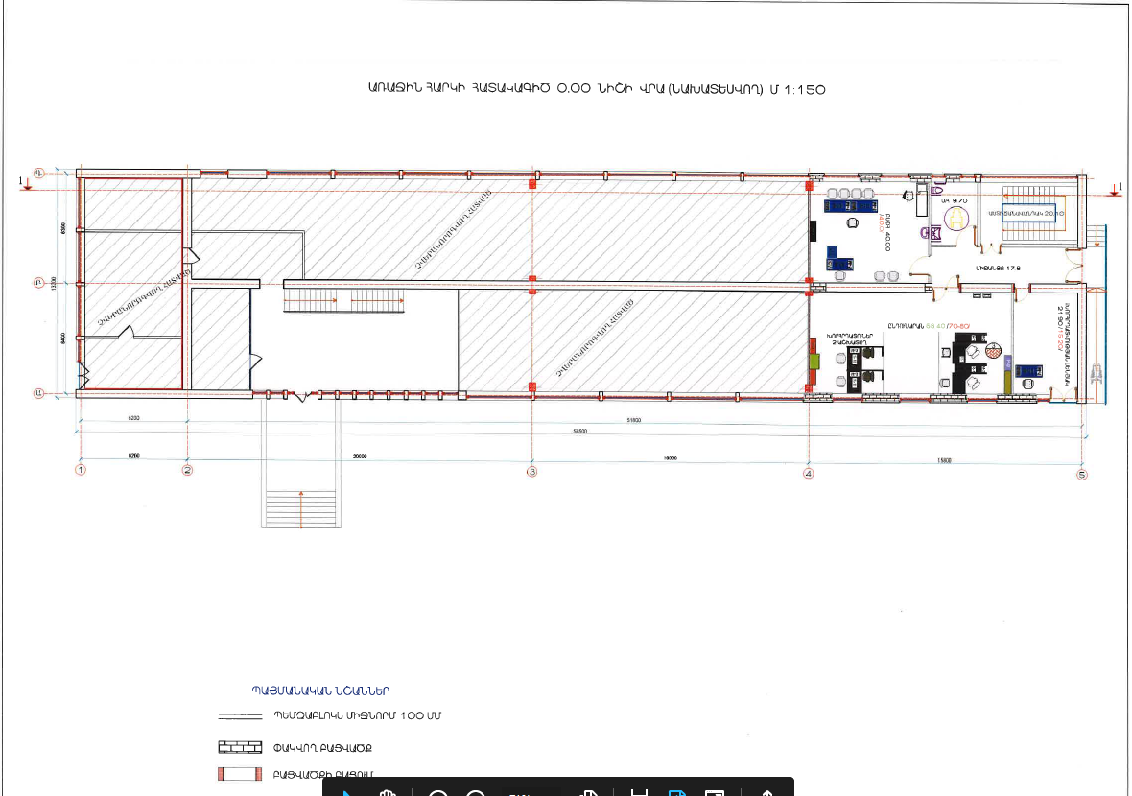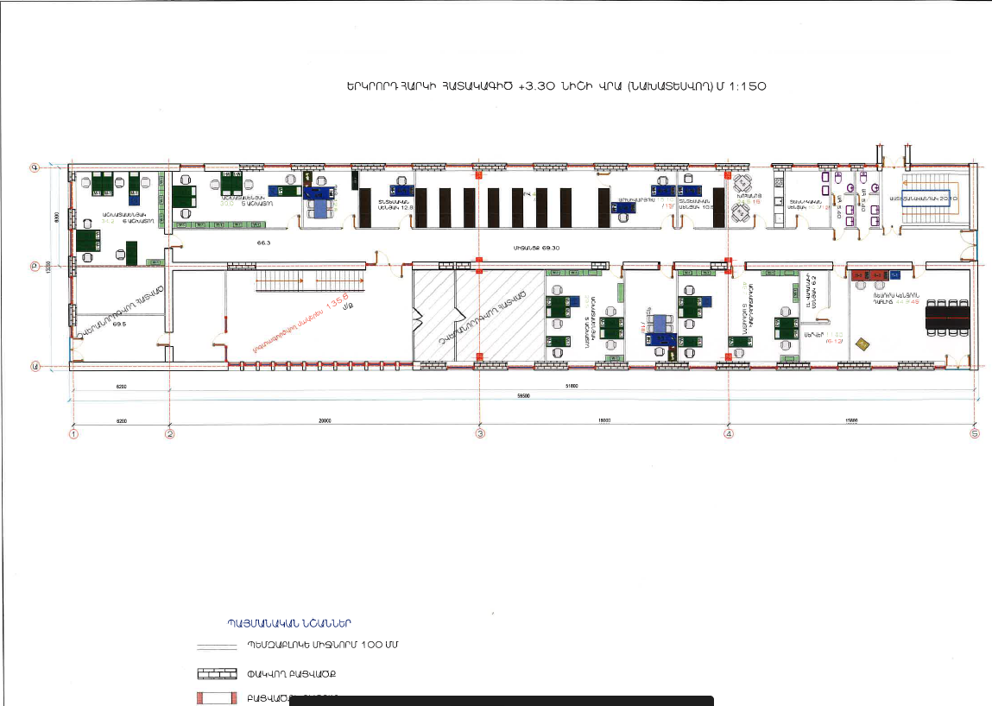
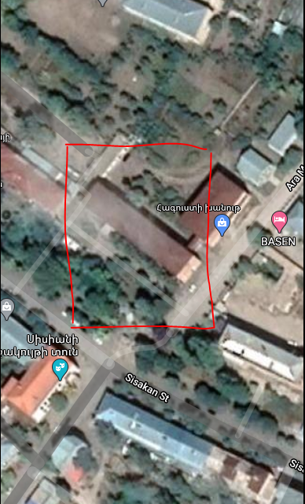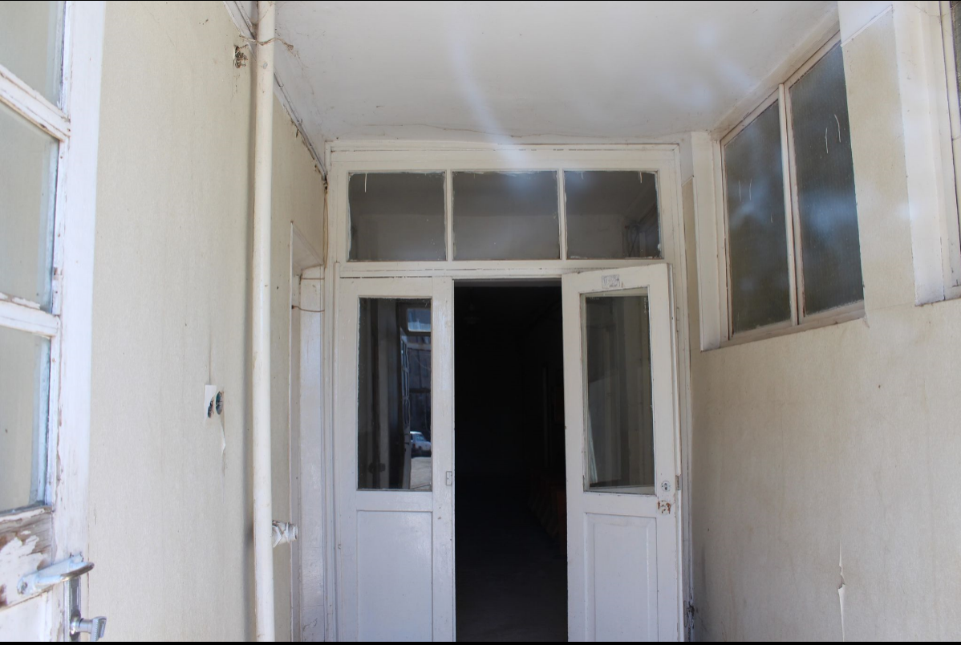

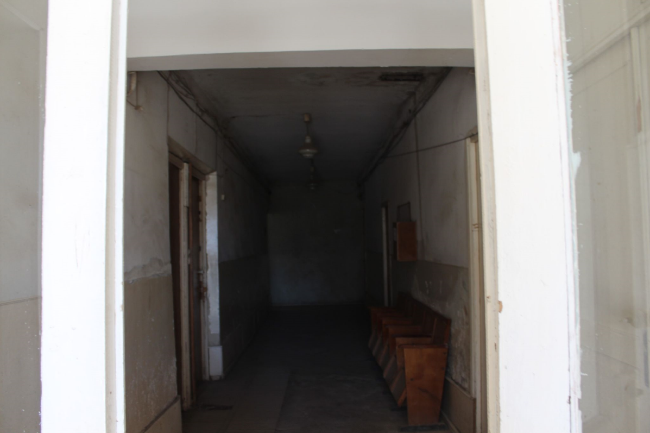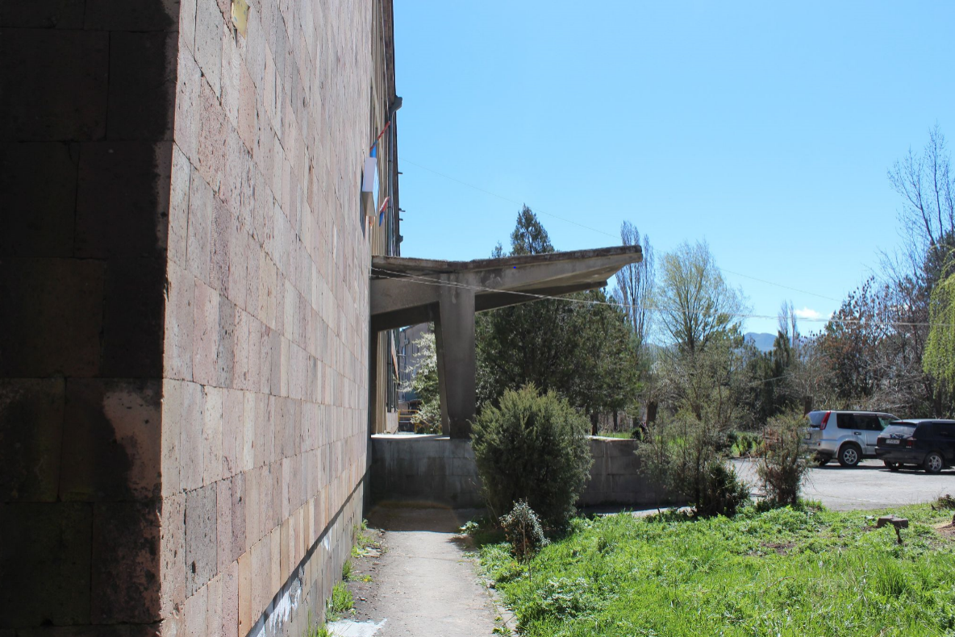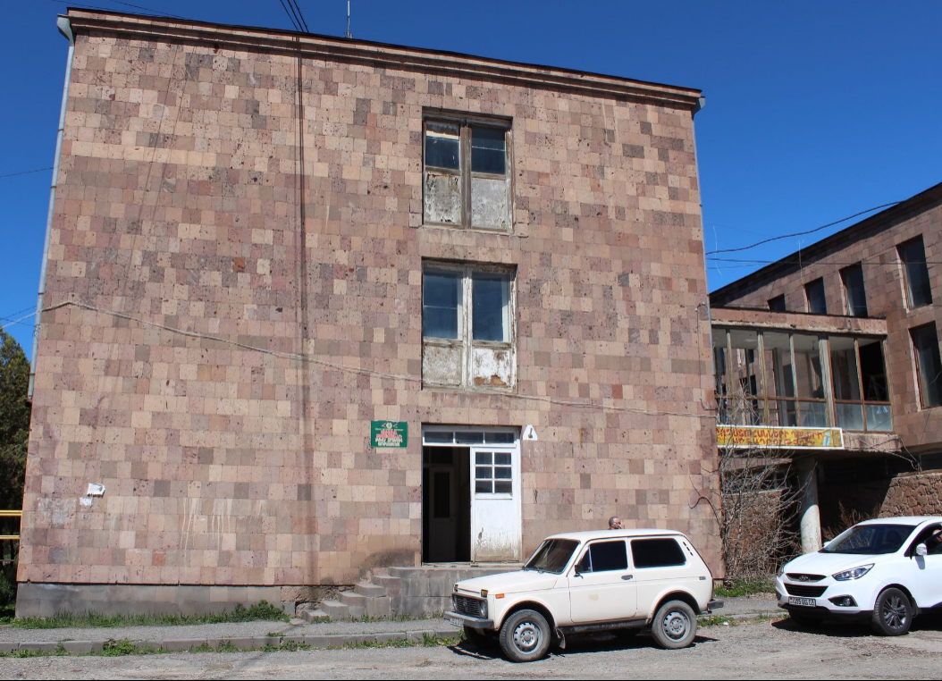

Attachment 2
Premises Ownership Certificate

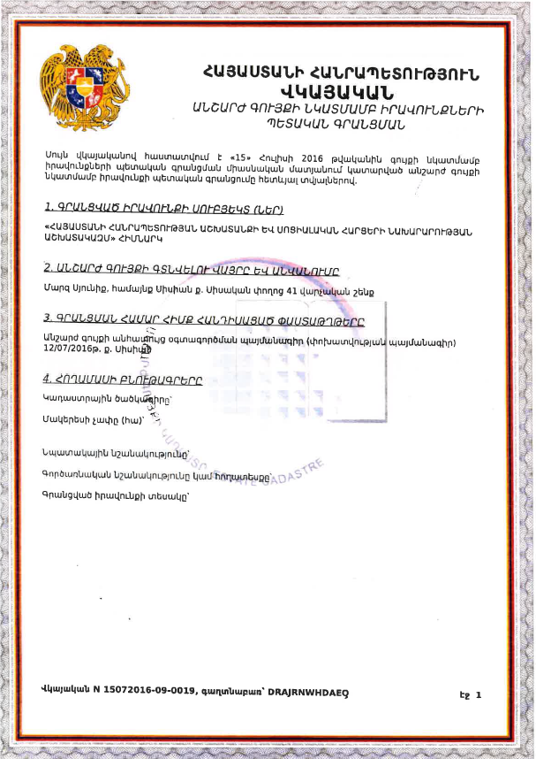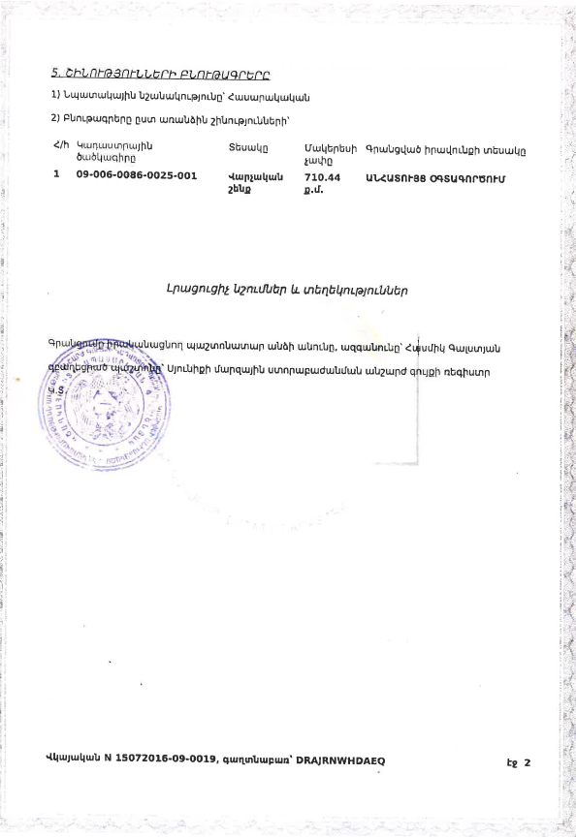

(Non-official translation)
Republic of Armenia
Certificate of State Registration of the Rights over
Real Estate
Cadaster Committee

This Certificate confirms the state registration of the rights over real estate in the integrated registry of state registration of rights over real estate on July 15, 2016 by the following details:
1. Entity(s) of registered right
Ministry of Labor and Social Affairs of the Republic of Armenia
2. The place and name of the real estate
Administrative bld. 41 Sisakan str., Sisian community, Syunik Marz
3. Documents on which the registration is based
Free use contract over the real estate issued 12.07.2016
4. Land characteristics
Cadaster Code
Surface
Target use
Operational use
Type of registered right

5. Building characteristics
1) Target use – public
2) Characteristics of the separate buildings;

N | Cadaster Code | Type | Surface | Type of registered right
1 | 09-006-0086-0025-001 | Administrative bld. | 710.44 sq. m | free use

Additional Notes and Information

Registering official – Hasmik Galstyan
Position – Real estate register of Syunik subdivision of the State Committee of the Real Estate Cadaster adjunct to the RoA Government.

Certificate N 15072016-09-0019
Attachment 3.
Conclusion on the technical condition of the building

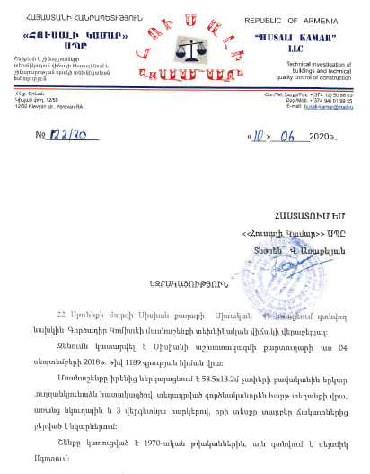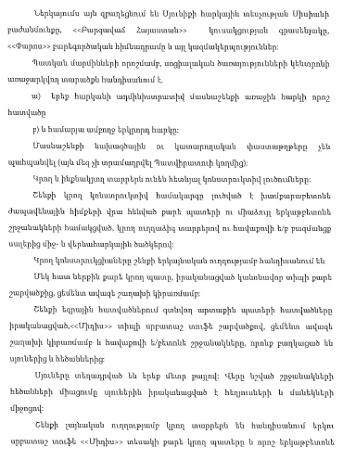
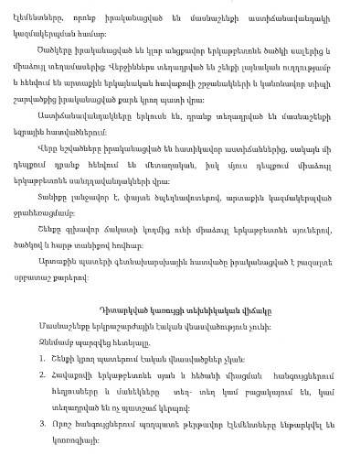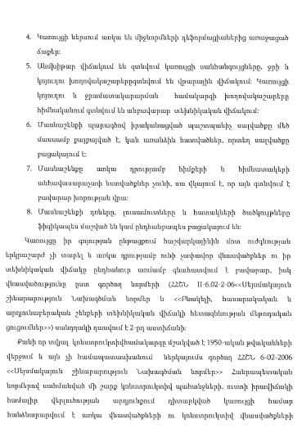
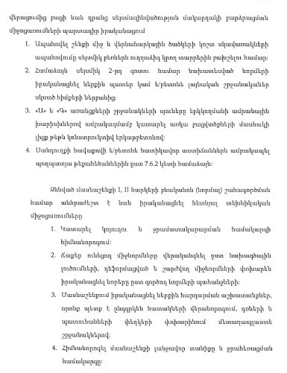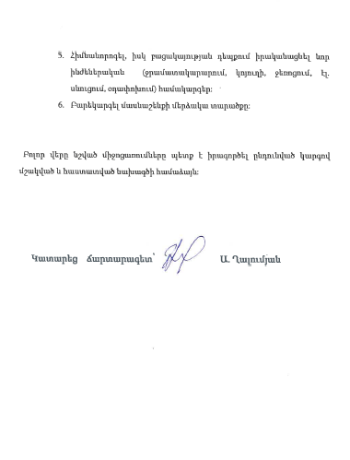

Summary-Excerpt from the

Conclusion on the Technical State of the Premises Envisaged for the Establishment of a Complex Social Services Territorial Center at Sisakan str. 41, Sisian community, Syunik marz, Republic of Armenia

The examination was implemented by “Husali Kamar” LLC (Technical investigation of buildings and technical quality control of constructions) based upon the letter N 1189 received from the Chief of Staff of Sisian Community administration, dated 04.09.2018.
The allocated premises are located on the first and second floors of the 3-storied administrative building constructed in 1970-s. According to this conclusion provided by “Husali Kamar” company, the building needs to undergo seismic strengthening.

Visual examination revealed:

It is necessary to take the following technical measures to ensure proper operation of the 1st and 2nd floors of the examined building allocated for CSSTC:
- Rehabilitate the sewage and water supply systems, renovate the bathrooms.
- Reconstruct the cracked and crooked partitions according to design solutions. Replace the deformed and unstable partitions in compliance with the acting norms.
- Implement internal finishing works, including renovation of floors, replacement of doors and windows with metal-plastic frames.
- Rehabilitate the roof and its drainage system.
- Renovate or replace the water supply, sewage, heating, electricity and ventilation systems.
- Improve the yard area.

Implement all the mentioned rehabilitation and renovation works in compliance with the agreed design and acting construction norms in the prescribed manner.

Engineer (sign/seal) A. Ghalumyan

Attachment 4. Records of Virtual Consultation Meeting

Attachment 5.
Waste disposal permission

SYUNIK MARZ OF THE REPUBLIC OF ARMENIA
HEAD OF SISIAN COMMUNITY

Sisakan str. 31, Sisian
Tel.: (0283) 2-33-30, Fax: (0283) 2-33-30
Web site: www.sisian.am
E-mail: sisiancity@mail.ru

N 1874
November 4, 2020

REFERENCE

This Reference is to confirm that the premises at Sisakan str. 41, Sisian, RoA Syunik Marz, where the future CSSTC will be established and civil works - implemented, are 7 km away from the community owned landfill in Aghitu settlement.

Head of the Community seal/sign A. Sargsyan

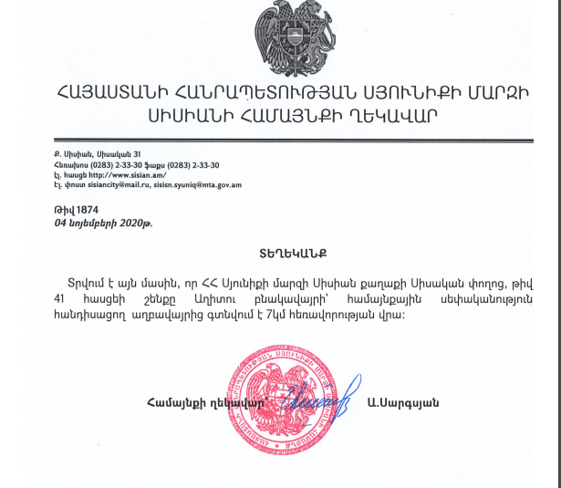

Attachment 6.
Construction Permit

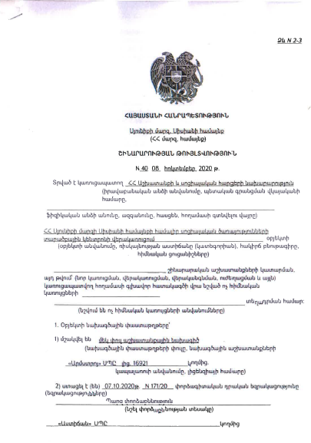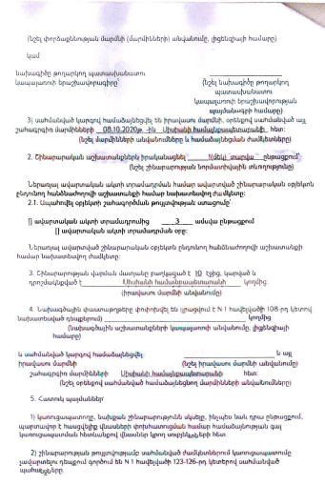

Land acquisitions includes displacement of people, change of livelihood encroachment on private property this is to land that is purchased/transferred and affects people who are living and/or squatters and/or operate a business (kiosks) on land that is being acquired.
Toxic / hazardous material includes but is not limited to asbestos, toxic paints, noxious solvents, removal of lead paint, etc.

