**REPUBLIC OF ARMENIA**

**MINISTRY OF LABOR AND SOCIAL AFFAIRS**

**SOCIAL PROTECTION ADMINISTRATION II PROJECT**

**LOAN N 5398-AM**

**ENVIRONMENTAL AND SOCIAL MANAGEMENT PLAN**

**CONSTRUCTION OF PREMISES**

**FOR SPITAK UNIFIED SOCIAL SERVICES TERRITORIAL CENTER**

**AUTHORS:**

Environmental Specialist **–** T. Tadevosyan

ME and Social Safeguards Specialist **–** N. Mkrtchyan

**MARCH 2021**

**PART A: General Project and Site Information**

|  |  |  |  |  |
| --- | --- | --- | --- | --- |
| **INSTITUTIONAL & ADMINISTRATIVE** | | | | |
| Country | Republic of Armenia | | | |
| Project title | Social Protection Administration II Project (SPAP II)  Construction of Premises for Spitak Unified Social Services Territorial Center (USSCT) in Lori Marz | | | |
| Scope of site-specific activity | The total area of the land plot allocated for the construction is 3506.2 square meters. The new two-story building will occupy an area of 22m×15.5m (L×W) with total area of 750 sq. m. The area of each floor will be 377.8 sq. m. Building’s yard will occupy an area of 3128.4 sq. m, including asphalt pavement - 1840 sq. m, tiled area – 260 sq. m, and lawn – 1625 sq. m.  The following activities will be carried out at the construction site: earthworks, construction of the building, installation of doors, windows, stained-glass windows, interior and exterior decoration works, construction of internal cold and hot water supply system, internal sewerage and drainage systems, ventilation system, installation of lighting and power distribution equipment, construction of computer, phone, and video surveillance networks, installation of outdoor lighting, construction of external water supply and sewerage systems, construction of gas supply pipeline, landscaping and yard improvement works. | | | |
| Institutional arrangements (WB) | Task Team Leaders:  Ivan Drabek,  Natalia Millan, Lucia Solbes Castro | | Safeguards Specialists:  Hmayak Avagyan, Environment  Vera Dugandzic, Social | |
| Implementation arrangements (RoA) | Implementing entity:  Ministry of Labor and Social Affairs (MLSA) | Works supervisor:  MLSA:  Tovmas Tadevosyan, Environment  Nvard Mkrtchyan,  Social | | Works contractor:  (TBD)  “Gevorgyan and Nerisyan” LLC and “ISHK” LLC joint venture |
| **SITE DESCRIPTION** | | | | |
| Name of institution whose premises are to be rehabilitated | |  | | --- | |  |   Spitak USSCT in Lori Marz | | | |
| Address and site location of institution whose premises are to be rehabilitated | Land plot at 87 Yerevan Highway, Spitak community, Lori Marz, Republic of Armenia | | | |
| Who uses the land (formal/informal)? | The land-owner of the land plot is the Spitak community.  The document confirming the real estate acquisition right is the Certificate of State Registration of the Rights over Real Estate N 06-0031, issued 20.02.2020 (ownership), Certificate of State Registration of the Rights over Real Estate N 02-0038, registered on 14.02.2020. (Attachment 2).  The construction works will not entail any physical displacement (relocation or loss of shelter) or economic displacement (loss of assets or access to assets that leads to loss of income sources or means of livelihood). | | | |
| Description of physical and natural environment around the site | The allocated land is in the suburban part of the Spitak community. Being located in a developed area, there is no wildlife within the area of construction activities. There are residential houses 135 m away from one side and 275 m away from the other side of the construction site and stores and a polyclinic 100 m away. The roads leading to the construction site are asphalted.  The electricity will be supplied from the nearest electric substation, which is 200 m away.  The new water supply 1520 m pipeline will be underground and laid in a 1.3m deep trench, which will be dug out and promptly reinstated upon closure. The natural gas supply 380 m pipline will be above ground. The 63 m sewage pipeline will be connected to the existing sewage network. The route for utility networks lies along the roadside of a public road. No trees or bushes are hindering the construction works.  The civil works will not interfere with the everyday life of nearby residents or public transportation. The project implementation will not have any temporary or permanent impacts on neighboring businesses.  There is enough space for parking construction vehicles and machinery and establishing temporary storage for building materials and construction waste on the land plot allocated for the construction of the new building.  Construction works will take 435 days.  The project’s Social and Environmental Specialists have visited and pre-screened the site. | | | |
| Locations and distance for material sourcing, especially aggregates, water, stones? | The necessary aggregates and other construction materials are available from nearby vendors and wholesale trade centers.  The water for the construction works will be supplied through the water supply pipeline of the nearby policlinic. | | | |
| **LEGISLATION** | | | | |
| National & local legislation & permits that apply to project activity | The following Armenian legislation defines a legal framework applicable to project activities:  - **Law on Atmospheric Air Protection of RoA (1994).**  The purpose of Law on Atmospheric Air Protection is to define the main principles of the RoA, directed to the provision of purity of atmospheric air and improvement of air quality, prevention and mitigation of the chemical, physical, biological and other impacts on air quality and regulation of public relation, as well as the principle of setting standards of emission limits on atmospheric air pollutants and permissible physical harmful influences.  *According to this law, the contractor shall undertake construction activities as well as transportation and temporary storage of wastes the way to minimize dust and other emissions to the air.*  - **RoA Law on Waste (2004).**  The law provides the legal and economic basis for the collection, transportation, disposal, treatment, re-use of wastes as well as prevention of negative impacts of waste on natural resources, human life and health. The law defines the roles and responsibilities of the state authorized bodies as well as of waste generator organizations in waste management operations.  *According to this law, the waste generated during the construction works should be recycled as appropriate or disposed of in designated locations.*  - **RoA Law on Environmental Impact Assessment and Expertise (2014)**  The law defines types of activities that are subject to environmental impact assessment and ecological expertise.  *According to this law, the construction of a new building for the Spitak USSCT is not subject to ecological expertise (the building areas is less than 1500 sq.m).*  - **Land Code of the Republic of Armenia (2001)**  Taking into account the nature protection, economic and social significance of the land, the Land Code defines the basic directions of the State regulatory system concerning land relations, development of various organizational and legal forms of land economy, fertility of land, land use efficiency raise, protection and improvement of an environment – favorable for human vitality and health, the legal framework concerning the protection of the rights on land, as well as regulation of resettlement and evacuation problems.  *Construction of the new building for Spitak USSCT will not cause resettlement either as defined by this law or as by OP/BP 4.12 of the World Bank.*  - **RoA Law on Urban Development (1998).**  The law defines types of activities that are subject to the construction permit.  *According to this law, the construction of a building for Spitak USSCT requires obtaining the construction permit.* | | | |
| **PUBLIC CONSULTATION** | | | | |
| When / where the public consultation process will take /took place | The draft ESMP was disclosed through the webpage of MLSA ([www.mlsa.am](http://www.mlsa.am)) and the Ashtarak community website (www.ashtarak.am) in Armenian and English languages upon clearance by the World Bank on 30.03.2021. During the public consultation period with duration of 7 working days no feedback, questions or comments have been received from stakeholders, beneficiaries, or other interested parties.  Brief information on the planned works and contact information of the contractor for addressing questions and grievances will be placed at the worksite and/or in its immediate surroundings. | | | |
| **ATTACHMENTS** | | | | |
| Attachment 1: Building layout and photos of the land plot  Attachment 2: Land ownership certificate  Attachment 3: Records of the public consultation meeting on the draft ESMP (to be provided)  Attachment 4: Waste disposal permit  Attachment 5: Construction Permit | | | | |

**PART B: safeguards information**

|  |  |  |  |
| --- | --- | --- | --- |
| **ENVIRONMENTAL /SOCIAL SCREENING** | | | |
| Will the site activity include/involve any of the following? | **Activity/Issue** | **Status** | **Triggered Actions** |
| 1. Building rehabilitation | [ ] Yes [✓] No | If “Yes”, see Section A below |
| 1. New construction | [✓] Yes [ ] No | If “Yes”, see Section A below |
| 1. Individual wastewater treatment system | [ ] Yes [✓] No | If “Yes”, see Section B below |
| 1. Historic building(s) and districts | [ ] Yes [✓ ] No | If “Yes”, see Section C below |
| 1. Acquisition of land[1] | [ ] Yes [✓] No | If “Yes”, see Section D below |
| 1. Hazardous or toxic materials[2] | [ ] Yes [✓] No | If “Yes”, see Section E below |
| 1. Impacts on forests and/or protected areas | [ ] Yes [✓] No | If “Yes”, see Section Fbelow |
| 1. Traffic and Pedestrian Safety | [✓ ] Yes [ ] No | If “Yes”, see Section H below |
| 1. Social Risk Management | [✓ ] Yes [ ] No | If “Yes”, See Section **I** below |

**PART C: Mitigation measures**

|  |  |  |
| --- | --- | --- |
| **ACTIVITY** | **PARAMETER** | **MITIGATION MEASURES CHECKLIST** |
| General Conditions | Notification and Worker Safety | 1. The local construction and environment inspectorates and communities have been notified of upcoming activities 2. The public has been notified of the works through appropriate notification in the media and/or at publicly accessible sites (including the site of the works) 3. All legally required permits have been acquired for construction and/or rehabilitation 4. The Contractor formally agrees that all work will be carried out in a safe and disciplined manner designed to minimize impacts on neighboring residents and environment. 5. Workers’ PPE will comply with international good practice (always hardhats, as needed masks and safety glasses, harnesses and safety boots) 6. Appropriate signposting of the sites will inform workers of key rules and regulations to follow. |
| **A.** General Rehabilitation and /or Construction Activities | Air Quality | 1. Demolition debris shall be kept in controlled area and sprayed with water mist to reduce debris dust 2. During pneumatic drilling/wall destruction, dust shall be suppressed by water spraying and/or installing dust screen enclosures at site 3. The surrounding environment (sidewalks, roads) shall be kept free of debris to minimize dust 4. There will be no open burning of construction / waste material at the site 5. There will be no excessive idling of construction vehicles at sites |
| Noise | 1. Construction noise will be limited to restricted times agreed to in the permit. The civil works will cause some noise mostly in defined working hours, however the Contractor shall maximally reduce inconvenience caused to the nearby residents 2. During operations the engine covers of generators, air compressors and other powered mechanical equipment shall be closed, and equipment placed as far away from residential areas as possible |
| Water Quality | 1. The site will establish appropriate erosion and sediment control measures such as e.g. hay bales and / or silt fences to prevent sediment from moving off site and causing excessive turbidity in nearby streams and rivers. |
| Waste management | 1. Waste collection and disposal pathways and sites will be identified for all major waste types expected from demolition and construction activities. 2. Mineral construction and demolition wastes will be separated from general refuse, organic, liquid and chemical wastes by on-site sorting and stored in appropriate containers. 3. Construction waste will be collected and disposed properly by licensed collectors 4. The records of waste disposal will be maintained as proof for proper management as designed. 5. Whenever feasible the contractor will reuse and recycle appropriate and viable materials (except asbestos) |
| **H.** Traffic and Pedestrian Safety | Direct or indirect hazards to public traffic and pedestrians by construction  activities | In compliance with national regulations, the contractor will insure that the construction site is properly secured, and construction-related traffic regulated. This includes but is not limited to   * Signposting, warning signs, barriers and traffic diversions: site will be clearly visible, and the public warned of all potential hazards * Traffic management system and staff training, especially for site access and near-site heavy traffic. Provision of safe passages and crossings for pedestrians where construction traffic interferes. * Adjustment of working hours to local traffic patterns, e.g. avoiding major transport activities during rush hours or times of livestock movement * Active traffic management by trained and visible staff at the site, if required for safe and convenient passage for the public. * Ensuring safe and continuous access to office facilities, shops and residences during renovation activities, if buildings stay open for public. |
| **I.** Social Risk Management | Public relationship management | 1. Assign local liaison person who is in charge of communication with and receiving requests/complaints from local population. 2. Consult local communities to identify and proactively manage potential conflicts between an external workforce and local people. 3. Raise local community awareness about sexually transmitted disease risks associated with the presence of an external workforce and include local communities in awareness activities. 4. Scheduled works beyond irrigation season to the extent possible in order to avoid/minimize service disruption. Inform local population about construction and work schedules, interruption of services, traffic detour routes and provisional bus routes, blasting and demolition, as appropriate. 5. Limit construction activities at night. When necessary, carefully schedule night work and inform the affected community beforehand. 6. Properly mark and fence work site 7. No temporary storage of construction materials and waste occurs within cultivated land plots or any type of private property 8. Allocate areas for the temporary storage of construction materials and waste so that free movement of traffic and pedestrians is not hindered. |
| Labor management | 1. To the extent possible, do not locate work camps in close proximity to local communities. 2. Locate and operate workers’ camps in consultation with neighboring communities. 3. Recruit unskilled or semi-skilled workers from local communities to the extent possible. Where and when feasible, worker skills training, should be provided to enhance the participation of local people. 4. Provide adequate lavatory facilities (toilets and washing areas) in the worksite with adequate supplies of hot and cold running water, soap, and hand drying devices. Establish a temporary septic tank system for any residential labor camp without causing pollution of nearby watercourses. 5. Raise awareness of workers on overall relationship management with local population, establish the code of conduct in line with international practice and strictly enforce them, including the dismissal of workers and financial penalties of adequate scale. |

**PART D: Monitoring Plan**

|  |  |  |  |  |  |  |
| --- | --- | --- | --- | --- | --- | --- |
| **Activity** | **What**  (Is the parameter to be monitored?) | **Where**  (Is the parameter to be monitored?) | **How**  (Is the parameter to be monitored?) | **When**  (Define the frequency / or continuous?) | **Why**  (Is the parameter being monitored?) | **Who**  (Is responsible for monitoring?) |
| **CONSTRUCTION PHASE** | | | | | | |
| Provision of construction materials | Purchase of construction materials from the registered providers | Provider’s office or warehouse | Verification of labels of the materials and/or certificates | During the conclusion of supply contracts | Ensure reliability of construction materials and their safety for human health | MLSA  Technical Supervision Company |
| Earthworks | * Topsoil removal and temporary stockpiling for re-cultivation of the land; * Temporary storage of excavated soil at determined places; * Backfilling of the excavated ground as needed and disposal of the excess mass to the places, approved in writing; * Immediate termination of activities in case of unexpected archaeological findings and providing of full information to the State Agency for Historical and Cultural Monuments Protection | Construction site | Inspection of activities | During earth works | * Limit loss of vegetation due to ground piling and minimization of pollution of surface waters with particles; * Limit pollution with contaminated soil of surface and ground waters; * Avoid loss of cultural heritage | MLSA  Technical Supervision Company  State Agency for Historical and Cultural Monuments Protection |
| Dust generation | * Dust suppression at worksites | Construction site | Visual inspection | Recurrent | * Reduce risks for the staff and neighboring communities | MLSA  Technical Supervision Company |
| Extraction of inert material | * Purchase of inert materials from the existing suppliers, if there is such opportunity * Obtaining of the license for production of inert materials and strict compliance with the license * Terracing of quarries, backfilling of exploited areas and harmonization with the landscape * Excavating gravel outside water flow, arrangement of separating ridges between water flow and excavation area, banning entrance of watery by vehicles and machinery | Quarries of inert materials | Inspection of documents  Inspection of activities | During excavation and reclamation at quarries | * Limit slope erosion and landscape damage * Limit erosion of river banks, pollution of water flow with weighted particles and disturbance of aquatic life | MLSA  Technical Supervision Company  Inspectorate for Nature Protection and Mineral Resources |
| Generation of construction waste | * Temporary storage of construction waste in especially allocated areas; * Timely disposal of wastes to the formally designated locations | Work site  Waste disposal site | Inspection of activities | Periodically during construction and upon its completion | * Prevent pollution of territory * Avoid accidents at the construction site due to scattered fragments of construction materials and debris * Retain esthetic appearance of the construction site and its surroundings | MLSA  Technical Supervision Company |
| Transportation of construction materials and waste | * Technical condition of vehicles and machinery; * Confinement and protection of truck loads with lining; * Respect of the established hours and routes of transportation | - Construction site  - Routes of transportation of construction materials and wastes | Inspection of roads adjacent to the construction object in the direction of the movement route | Selective inspections during work hours | * Limit pollution of soil and air from emissions; * Limit nuisance to local communities from noise and vibration; * Minimize traffic disruption. | MLSA  Technical Supervision Company  Traffic Police |
| Production of domestic wastes | Placement of domestic waste collection containers and arrangement on periodic transportation of waste | Construction site | Inspection | Total period of operation | * Prevent pollution of soil and water; * Retain esthetic appearance of the sites area and its surroundings | MLSA  Technical Supervision Company |
| Production of liquid wastes | Arrangement and maintenance of toilets in compliance with sanitation norms at the construction site and construction base | Construction site and construction base | Visual observation | Total period of construction | Reduce pollution of surface and ground waters | MLSA  Technical Supervision Company |
| Operation of asphalt-concrete plant, | * Obtaining of emission permit by the construction contractor and strict compliance with it * Selection of a place for the plant that provides minimal disturbance of population with noise, dust and exhaust * Arrangement of sedimentation pond for waste water from the plant | Construction site and construction base | Inspection of documents  Inspection of activities | Total period of plant operation | * Limit population disturbance near the construction site * Limit atmospheric air and surface water pollution | MLSA  Technical Supervision Company |
| Maintenance of construction equipment | * Washing of cars and construction equipment outside the construction site or at maximum distance from natural streams; * Refueling or lubrication of construction equipment outside the construction site or at the predetermined confined area. | Construction site | Inspection of activities | Selective inspections during work hours | * Avoid pollution of water and soil with oil products due to the operation of equipment; * Timely localize and decrease expected damage in case of fire. | MLSA  Technical Supervision Company |
| Workers’ health and safety | * Provision of constructors with working clothes and PPE; * Strict compliance with the rules of construction equipment operation and usage of PPE; * Availability of labor safety training and instruction records. * Strict compliance with national regulations for construction works and the rules of construction equipment operation; * Presence of fire extinguishing and medical aid kits at the work site | Work site | Inspection | Entire period of works | * Reduce the probability of traumas and accidents | MLSA  Technical Supervision Company |
| Traffic and road safety | * Presence of traffic regulation and warning signs as needed; * Construction site demarcated/fenced, and all construction activities confined to the site; * No construction materials and waste piled up or scattered outside the construction site | Roads adjacent to the construction object | Inspection | Entire period of construction works | * Prevent the violation of interests of the passengers and/or pedestrians because of the construction works | MLSA  Technical Supervision Company  Traffic Police |
| Construction site re-cultivation and landscaping | * Dismantlement of construction base and harmonization of the areas with the landscape * Final cleaning of the construction site and permanent access roads and landscaping-greening of the area. | Construction site, construction base and temporary access roads (if any) | Inspection of activities | Final period of construction | Reduce loss of aesthetical value of the landscape | MLSA  Spitak Municipality  Technical Supervision Company |
| Works near privately-owned land plots and other property | * Avoiding trespassing or incidental damaging of private property (using small-size machinery or manual labour near walls and fences, stockpiling of construction material and waste away from private property; etc.); * In case of unintended damage to private property, quickly restore it to the original or better status; * In case of expected temporary impact on privately-owned property, inform owners upfront and guarantee restoration, acquire written consent of owners for intervention, and promptly restore the damage to the original or better status. | Works near privately-owned land, buildings and other assets | Monitoring and inspection | Entire period of construction | * Reduce the probability of damages to private property; * Exclude temporary or permanent violation of ownership and/or user rights on the private property | MLSA  Technical Supervision Company |
| Public information and grievance redress | Information board installed at the work site carrying:  - the name of works provider (contractor), works commissioner (MLSA), and works financing Project (SPAP);  - contact information / hotline in MLSA for local communities to refer complains on the nuisance caused by construction works | Field office of the contractor and construction site | Inspection of documents | Before and during the construction works | Communicate with the residents or employees as well as other stakeholders of the area adjacent to the construction site and register the complaints | MLSA |
| COVID-19 preparedness in the work site | * Provision of handwash facilities in the work site with adequate supplies of running water, hand soap, alcohol-based hand sanitizer and hand drying devices; * Worksite entrance procedure and medical checks; * Regular disinfection of public rooms, equipment, tools, and waste; * Work practices to reduce or minimize contact between workers; * Provision of face masks and other relevant PPE to all project workers at the entrance to the project site. | Construction site | Inspection of activities | Total period of works | Reduce the COVID-19 infection risk at worksites | MLSA  Technical supervision company |
| **OPERATION PHASE** | | | | | | |
| Operational waste management | - Organized collection of household waste generated during office operation inside USSCT;  - Arrangements in place and operational for removal of household waste from USSCT | Premises of the USSCT | Site inspection | Total period of operation of the USSCT | Ensure sanitary safety and favorable conditions for USSCT staff and visitors | USSCT administration |
| Maintenance of internal building systems | Electric wiring and water/sewage pipes maintained in good operating condition | Premises of the USSCT | Periodic check-ups | Total period of operation of the USSCT | Exclude risks of electric shocks, short circuits, and leakage of pipes | USSCT administration |
| Improved space (premises) | Exterior area of the building kept clean and groomed | Premises of the USSCT | Visual Inspection | Total period of operation of the USSCT | Ensure favorable social impact of the improved premises on the beneficiaries attending the center | USSCT administration |
| Emergency preparedness | Presence of fire localization system, and emergency back-up system for the case of failure of the boiler-based heating system | Premises of the USSCT | Periodic check-ups | Total period of operation of the USSCT | * Reduce risks for the staff and visitors of the USSCT * Avoid disruption of USSCT’s operation and a nuisance to staff and visitors | USSCT administration |
| Operation and maintenance of heating and ventilation systems | Regular servicing of the entire heating and ventilation systems being undertaken | Premises of the USSCT | Periodic check-ups | Total period of operation of the heating and ventilation systems | Maintenance of heating and ventilation systems in safe and operable condition | Contractor  USSCT administration |

**Attachment 1. Building layout and**

**photos of the land plot**

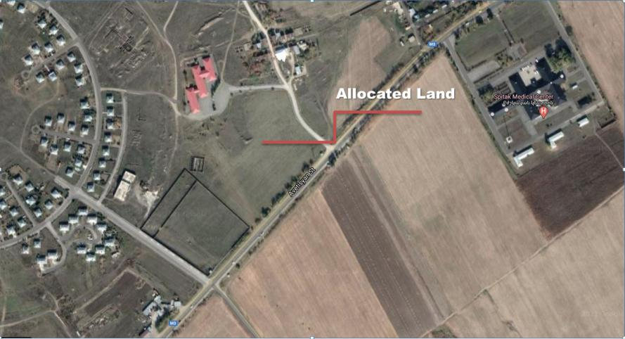

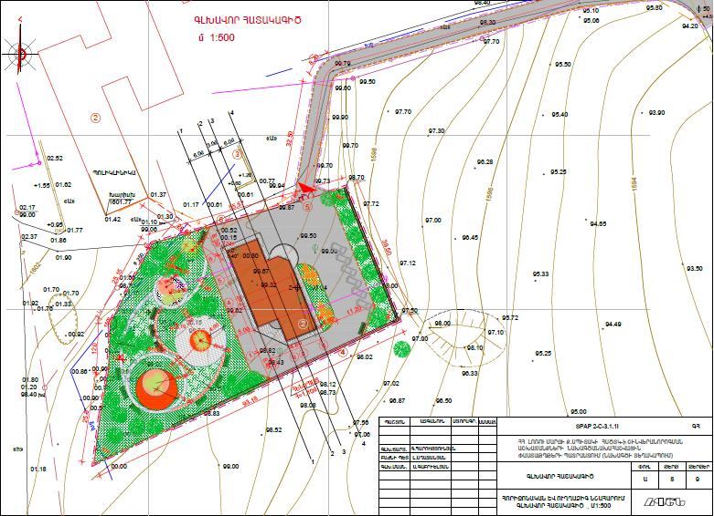

**Attachment 2**

**Land plot ownership certificate**

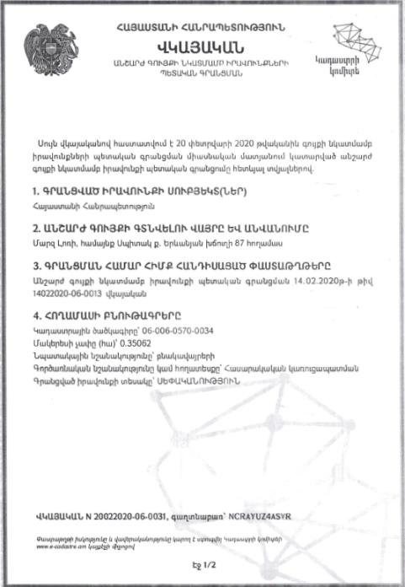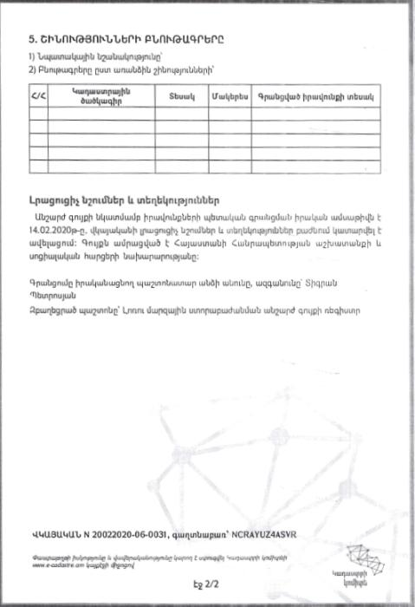

**(Non-official translation)**

**Republic of Armenia**

**Certificate of State Registration of the Rights over**

**Real Estate**

**Cadaster Committee**

This Certificate confirms the state registration of the rights over real estate in the integrated registry of state registration of rights over real estate on February 20, 2020 by the following details:

1. **Entity(s) of registered right**

Republic of Armenia

2. **The place and name of the real estate**

Land plot located at 87 Yerevan Highway Spitak community, Lori Marz

**3. Documents on which the registration is based**

Certificate confirming the state registration of the rights over real estate N 14022020-06-0013, registered on 14/02/2020

**4. Land characteristics**

Cadaster Code 06-006-0570-0034

Surface – 0.35062 ha

Target use - residential

Operational use – public construction

Type of registered right – Ownership

**5. Building characteristics**

1) Target use – public

2) Characteristics of the separate buildings;

|  |  |  |  |  |
| --- | --- | --- | --- | --- |
| N | Cadaster Code | Type | Surface | Type of registered right |
| 1 | 06-006-0570-0034 | Land plot | 0.35062 ha | Ownership |
|  |  |  |  |  |

**Additional Notes and Information**

The State registration of the rights over the real estate was made on 14.02.2020. The real estate is attached to the RA Ministry of Labor and Social Affairs.

Registering official – Tigran Petrosyan

Position – Real estate register of Lori Marz subdivision of the State Committee of the Real Estate Cadaster adjunct to the RoA Government.

Certificate N 20022020-06-0031

**Attachment 4. Records of Virtual Consultation Meeting**

Date: 12.04.2021

Period of public consultation: 30.03.2021 – 09.04.2021

To prevent the spread of the COVID-19 in Armenia and protect public health, the public consultation activities on the draft ESMP for the construction of the premises for Spitak USSCT in the RoA Lori Marz were carried out online.

The draft Environmental and Social Management Plan (ESMP) for the construction of the premises for Spitak USSCT was publicly disclosed on March 30, 2021, on the official websites of the RoA MLSA and Spitak community to solicit stakeholder feedback and comments (the announcement of public consultation along with the link to the draft ESMP can be found on <https://www.mlsa.am/?page_id=9330>, <http://www.spitak.am/Pages/Misc/Announces/view.aspx?recID=325#.YHQ4JigzaUk>)

Also, an official letter has been sent to the local Heads of Services which will be integrated into the future USSCT, particularly detailing:

1. Major changes in the process of introduction of the Integrated Social Services System in the RoA social protection system;
2. The potential environmental risks and impacts associated with the construction of the premises for Spitak USSCT and proposed mitigation and monitoring measures to address the impacts; and
3. The potential social risks and impacts associated with the establishment of Spitak USSCT and proposed mitigation and monitoring measures.

During the public consultation period no feedback, questions or comments have been received from stakeholders, beneficiaries, or other interested parties.

**Attachment 5.**

**Waste disposal permit**

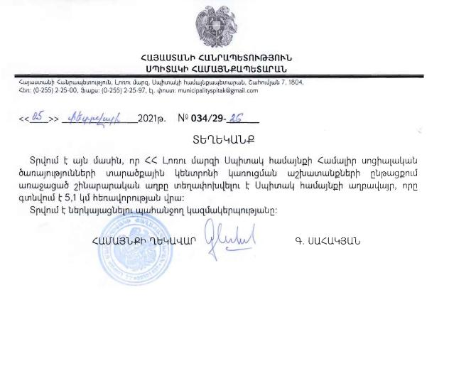

**REPUBLIC OF ARMENIA**

**SPITAK MUNICIPALITY**

**7 Shahumyan str., Spitak community, Lori Marz, RA, 1804**

**Tel.: (0255) 2-25-00, fax: (0255) 2-25-97**

**E-mail: municipalityspitak@gmail.com**

**N 034/29-26**

**February 05, 2021**

**REFERENCE**

This Reference is to confirm that the construction waste generated during the construction works of the premises of Spitak Unified social services territorial center will be transported and disposed of at Spitak landfill located about 5.1 km away from the construction site.

Head of Community Seal/sign G. Sahakyan

**Attachment 6.**

**Construction Permit**

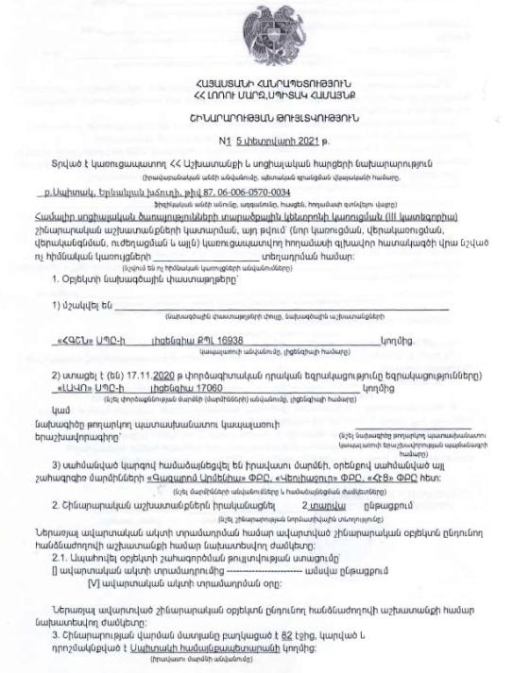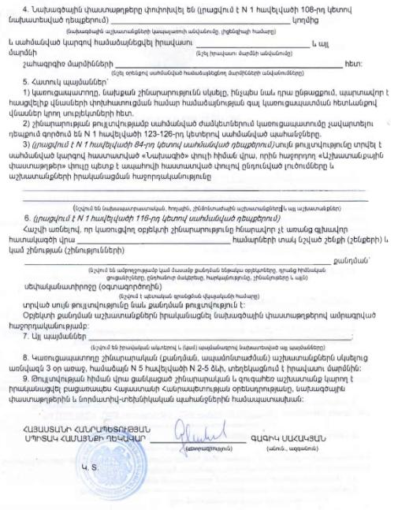

1. Land acquisitions includes displacement of people, change of livelihood encroachment on private property this is to land that is purchased/transferred and affects people who are living and/or squatters and/or operate a business (kiosks) on land that is being acquired.
2. Toxic / hazardous material includes but is not limited to asbestos, toxic paints, noxious solvents, removal of lead paint, etc.