**REPUBLIC OF ARMENIA**

**MINISTRY OF LABOR AND SOCIAL AFFAIRS**

**SOCIAL PROTECTION ADMINISTRATION II PROJECT**

**LOAN N 5398-AM**

**ENVIRONMENTAL AND SOCIAL MANAGEMENT PLAN**

**REHABILITATION OF PREMISES**

**FOR UNIFIED SOCIAL SERVICES TERRITORIAL CENTER**

**AUTHORS:**

Environmental Specialist **–** T. Tadevosyan

ME and Social Safeguards Specialist **–** N. Mkrtchyan

**MARCH 2021**

**PART A: General Project and Site Information**

|  |  |  |  |  |
| --- | --- | --- | --- | --- |
| **INSTITUTIONAL & ADMINISTRATIVE** | | | | |
| Country | Republic of Armenia | | | |
| Project title | Social Protection Administration II Project (SPAP II)  Rehabilitation of Premises for Ashtarak Unified Social Services Territorial Center (USSTC) in Aragatsotn Marz | | | |
| Scope of site-specific activity | The following works will be carried out on the existing building: seismic strengthening works as required by the conclusion of the technical expertise, removing old plaster from walls, strengthening of door openings, construction of internal engineering networks, installation of doors and windows, demolition of internal non-bearing partition walls, finishing walls and ceilings, mounting of internal infrastructure (heating, ventilation, and communication networks), rehabilitation of the roof and drainage system, construction of wheelchair ramps, installation of an elevator and reconstruction of the staircase.  Overall an area of 444.3 sq. m from the first and second floors of the 3-story building, and the entire third floor (424 sq. m) are allocated for the establishment of the USSTC. | | | |
| Institutional arrangements (WB) | Task Team Leaders:  Ivan Drabek,  Natalia Millan, Lucia Solbes Castro | | Safeguards Specialists:  Hmayak Avagyan, Environment  Vera Dugandzic, Social | |
| Implementation arrangements (RoA) | Implementing entity:  Ministry of Labor and Social Affairs (MLSA) | Works supervisor:  MLSA:  Tovmas Tadevosyan, Environment  Nvard Mkrtchyan,  Social | | Works contractor:  (TBD)  Agarak OJSC |
| **SITE DESCRIPTION** | | | | |
| Name of institution whose premises are to be rehabilitated | |  | | --- | |  |   Ashtarak USSTC in Aragatsotn Marz | | | |
| Address and site location of institution whose premises are to be rehabilitated | Hospital bld. 61/1 V. Petrosyan str., Ashtarak community, Aragatsotn Marz, Republic of Armenia | | | |
| Who uses the land (formal/informal)? | The land-owner of the construction site is the Ashtarak community.  The document confirming the real estate acquisition right is the Certificate of State Registration of the Rights over Real Estate N 02-0037, issued 24.05.2019 (ownership), Certificate of State Registration of the Rights over Real Estate N 02-0038, registered on 20.02.2018. (Attachment 2).  The premises are located in the unused hospital building of the Ashtarak community, thus, the renovation works will not entail any physical displacement (relocation or loss of shelter) or economic displacement (loss of assets or access to assets that leads to loss of income sources or means of livelihood). | | | |
| Description of physical and natural environment around the site | The premises allocated for the USSTC are in the central part of the Ashtarak community. There are residential houses, stores and other buildings nearby. The road leading to the center is asphalted. No trees or bushes are hindering the construction works.  The external electricity, water supply, sewage disposal and natural gas supply networks of the future USSTC are currently in place and will remain unchanged. The internal communication network (intranet, phone, securuty system) and infrastructure - electrical wiring and water pipelines will be fully replaced.  The civil works will not interfere with the everyday life of nearby residents or public transportation, as well as the activity of the nearby stores and the Culture house.  Construction works will take 18 months from start.  The project’s Social and Environmental Specialists have visited and pre-screened the site. | | | |
| Locations and distance for material sourcing, especially aggregates, water, stones? | The necessary aggregates and other construction materials are available from nearby vendors and wholesale trade centers.  Water required for construction works is available inside the building and is supplied by “Veolia Jur” CJSC.  There is enough space for parking construction vehicles and machinery on the territory adjacent to the USSTC building and to establish temporary storage for building materials and construction waste, if necessary. | | | |
| **LEGISLATION** | | | | |
| National & local legislation & permits that apply to project activity | The following Armenian legislation defines a legal framework applicable to project activities:  - **Law on Atmospheric Air Protection of RoA (1994).**  The purpose of Law on Atmospheric Air Protection is to define the main principles of the RoA, directed to the provision of purity of atmospheric air and improvement of air quality, prevention and mitigation of the chemical, physical, biological and other impacts on air quality and regulation of public relation, as well as the principle of setting standards of emission limits on atmospheric air pollutants and permissible physical harmful influences.  *According to this law, the contractor shall undertake repairs activities as well as transportation and temporary storage of wastes the way to minimize dust and other emissions to the air.*  - **RoA Law on Waste (2004).**  The law provides the legal and economic basis for the collection, transportation, disposal, treatment, re-use of wastes as well as prevention of negative impacts of waste on natural resources, human life and health. The law defines the roles and responsibilities of the state authorized bodies as well as of waste generator organizations in waste management operations.  *According to this law, the waste generated during the renovation of the building should be recycled as appropriate or disposed of in designated locations. According to this law, the contractor shall absorb costs of safe storage, transportation, and disposal of the waste.*  - **RoA Law on Environmental Impact Assessment and Expertise (2014)**  The law defines types of activities that are subject to environmental impact assessment and ecological expertise.  *According to this law, works for the renovation of premises for the Ashtarak USSTC are not subject to ecological expertise.*  - **Land Code of the Republic of Armenia (2001)**  Taking into account the nature protection, economic and social significance of the land, the Land Code defines the basic directions of the State regulatory system concerning land relations, development of various organizational and legal forms of land economy, fertility of land, land use efficiency raise, protection and improvement of an environment – favorable for human vitality and health, the legal framework concerning the protection of the rights on land, as well as regulation of resettlement and evacuation problems.  *Renovation of Ashtarak USSTC will not cause resettlement either as defined by this law or as by OP/BP 4.12 of the World Bank.*  - **RoA Law on Urban Development (1998).**  *According to this law, the renovation of the existing premises allocated for Ashtarak USSTC requires obtaining the construction permit.*  **- Law on State Regulation of Provision of Technical Safety of RoA (2005)**  This Law defines the legal, economic and social basis for the provision of technical safety in RoA, as well as the system of technical safety provision and regulates the relationship connected with technical safety.  *According to this law, design documentation for the installation of a new elevator at Ashtarak USSTC is subject to technical safety expertise. Prior to commissioning, the expert conclusion should confirm the compliance of the unit with design documentation. After commissioning, the elevator is subject to recording in the Register of Dangerous Production Units.* | | | |
| **PUBLIC CONSULTATION** | | | | |
| When / where the public consultation process will take /took place | The draft ESMP was disclosed through the webpage of MLSA ([www.mlsa.am](http://www.mlsa.am)), the Ashtarak community website (www.ashtarak.am), as well as the FB page of the Project in Armenian and English languages upon clearance by the World Bank on 24.02.2021. During the public consultation period from February 27 to March 5, 2021, no feedback, questions or comments have been received from stakeholders, beneficiaries, or other interested parties.  Brief information on the planned works and contact information of the contractor for addressing questions and grievances will be placed at the worksite and/or in its immediate surroundings. | | | |
| **ATTACHMENTS** | | | | |
| Attachment 1: Site plan and photo documentation of premises  Attachment 2: Premises ownership certificate  Attachment 3: Conclusion on the technical condition of the building  Attachment 4: Records of the public consultation meeting on the draft ESMP  Attachment 5: Waste disposal permit  Attachment 6: Construction Permit | | | | |

**PART B: safeguards information**

|  |  |  |  |
| --- | --- | --- | --- |
| **ENVIRONMENTAL /SOCIAL SCREENING** | | | |
| Will the site activity include/involve any of the following? | **Activity/Issue** | **Status** | **Triggered Actions** |
| 1. Building rehabilitation | [✓] Yes [ ] No | If “Yes”, see Section A below |
| 1. New construction | [] Yes [✓] No | If “Yes”, see Section A below |
| 1. Individual wastewater treatment system | [ ] Yes [✓] No | If “Yes”, see Section B below |
| 1. Historic building(s) and districts | [ ] Yes [✓ ] No | If “Yes”, see Section C below |
| 1. Acquisition of land[1] | [ ] Yes [✓] No | If “Yes”, see Section D below |
| 1. Hazardous or toxic materials[2] | [ ] Yes [✓] No | If “Yes”, see Section E below |
| 1. Impacts on forests and/or protected areas | [ ] Yes [✓] No | If “Yes”, see Section Fbelow |
| 1. Handling / management of medical waste | [ ] Yes [✓] No | If “Yes”, see Section G below |
| 1. Traffic and Pedestrian Safety | [✓ ] Yes [] No | If “Yes”, see Section H below |

**PART C: Mitigation measures**

|  |  |  |
| --- | --- | --- |
| **ACTIVITY** | **PARAMETER** | **MITIGATION MEASURES CHECKLIST** |
| General Conditions | Notification and Worker Safety | 1. The local construction and environment inspectorates and communities have been notified of upcoming activities 2. The public has been notified of the works through appropriate notification in the media and/or at publicly accessible sites (including the site of the works) 3. All legally required permits have been acquired for construction and/or rehabilitation 4. The Contractor formally agrees that all work will be carried out in a safe and disciplined manner designed to minimize impacts on neighboring residents and environment. 5. Workers’ PPE will comply with international good practice (always hardhats, as needed masks and safety glasses, harnesses and safety boots) 6. Appropriate signposting of the sites will inform workers of key rules and regulations to follow. |
| **A.** General Rehabilitation and /or Construction Activities | Air Quality | 1. Demolition debris shall be kept in controlled area and sprayed with water mist to reduce debris dust 2. During pneumatic drilling/wall destruction, dust shall be suppressed by water spraying and/or installing dust screen enclosures at site 3. The surrounding environment (sidewalks, roads) shall be kept free of debris to minimize dust 4. There will be no open burning of construction / waste material at the site 5. There will be no excessive idling of construction vehicles at sites |
| Noise | 1. Construction noise will be limited to restricted times agreed to in the permit. The civil works will cause some noise mostly in defined working hours, however the Contractor shall maximally reduce inconvenience caused to the nearby residents 2. During operations the engine covers of generators, air compressors and other powered mechanical equipment shall be closed, and equipment placed as far away from residential areas as possible |
| Water Quality | 1. The site will establish appropriate erosion and sediment control measures such as e.g. hay bales and / or silt fences to prevent sediment from moving off site and causing excessive turbidity in nearby streams and rivers. |
| Waste management | 1. Waste collection and disposal pathways and sites will be identified for all major waste types expected from demolition and construction activities. 2. Mineral construction and demolition wastes will be separated from general refuse, organic, liquid and chemical wastes by on-site sorting and stored in appropriate containers. 3. Construction waste will be collected and disposed properly by licensed collectors 4. The records of waste disposal will be maintained as proof for proper management as designed. 5. Whenever feasible the contractor will reuse and recycle appropriate and viable materials (except asbestos) |
| **H.** Traffic and Pedestrian Safety | Direct or indirect hazards to public traffic and pedestrians by construction  activities | In compliance with national regulations, the contractor will insure that the construction site is properly secured, and construction-related traffic regulated. This includes but is not limited to   * Signposting, warning signs, barriers and traffic diversions: site will be clearly visible, and the public warned of all potential hazards * Traffic management system and staff training, especially for site access and near-site heavy traffic. Provision of safe passages and crossings for pedestrians where construction traffic interferes. * Adjustment of working hours to local traffic patterns, e.g. avoiding major transport activities during rush hours or times of livestock movement * Active traffic management by trained and visible staff at the site, if required for safe and convenient passage for the public. * Ensuring safe and continuous access to office facilities, shops and residences during renovation activities, if buildings stay open for public. |

**PART D: Monitoring Plan**

|  |  |  |  |  |  |  |
| --- | --- | --- | --- | --- | --- | --- |
| **Activity** | **What**  (Is the parameter to be monitored?) | **Where**  (Is the parameter to be monitored?) | **How**  (Is the parameter to be monitored?) | **When**  (Define the frequency / or continuous?) | **Why**  (Is the parameter being monitored?) | **Who**  (Is responsible for monitoring?) |
| **CONSTRUCTION PHASE** | | | | | | |
| Provision of construction materials | Purchase of construction materials from the registered providers | Provider’s office or warehouse | Verification of labels of the materials and/or certificates | During the conclusion of supply contracts | Ensure reliability of construction materials and their safety for human health | MLSA  Technical Supervision Company |
| Generation of construction waste | * Temporary storage of construction waste in especially allocated areas; * Timely disposal of wastes to the formally designated locations | Work site  Waste disposal site | Inspection of activities | Periodically during construction and upon its completion | - Prevent pollution of territory  - Avoid accidents at the construction site due to scattered fragments of construction materials and debris  - Retain esthetic appearance of the construction site and its surroundings | MLSA  Technical Supervision Company |
| Transportation of construction materials and waste | * Technical condition of vehicles and machinery; * Confinement and protection of truckloads with lining; * Respect of the established hours and routes of transportation | - Construction site  - Routes of transportation of construction materials and wastes | Inspection of roads adjacent to the construction object in the direction of the movement route | Selective inspections during work hours | - Limit pollution of soil and air from emissions;  - Limit nuisance to local communities from noise and vibration;  - Minimize traffic disruption. | MLSA  Technical Supervision Company  Traffic Police |
| Maintenance of construction equipment | * Washing of cars and construction equipment outside the construction site or at maximum distance from natural streams; * Refueling or lubrication of construction equipment outside the construction site or at the predetermined confined area. | Construction site | Inspection of activities | Selective inspections during work hours | - Avoid pollution of water and soil with oil products due to the operation of equipment;  -Timely localize and decrease expected damage in case of fire. | MLSA  Technical Supervision Company |
| Workers’ health and safety | * Provision of constructors with working clothes and PPE; * Strict compliance with the rules of construction equipment operation and usage of PPE; * Presence of fire extinguishing and medical aid kits at the work site | Work site | Inspection | Entire period of works | Reduce the probability of traumas and accidents | MLSA  Technical Supervision Company |
| Traffic and road safety | * Presence of traffic regulation and warning signs as needed; * Construction site demarcated/fenced, and all construction activities confined to the site; * No construction materials and waste piled up or scattered outside the construction site | Roads adjacent to the construction object | Inspection | Entire period of construction works | Prevent the violation of interests of the passengers and/or pedestrians because of the construction works | MLSA  Technical Supervision Company  Traffic Police |
| Site reinstatement | Land plot around the reconstructed premises cleared of any residual waste and reinstated | Construction site | Visual inspection | Final stage of works | Reduce loss of aesthetical value of the landscape due to construction activities | MLSA  Ashtarak Municipality  Technical Supervision Company |
| Public information and grievance redress | Information board installed at the work site carrying:  - the name of works provider (contractor), works commissioner (MLSA), and works financing Project (SPAP);  - contact information / hotline in MLSA for local communities to refer complains on the nuisance caused by construction works | Field office of the contractor and construction site | Inspection of documents | Before and during the construction works | Communicate with the residents or employees as well as other stakeholders of the area adjacent to the construction site and register the complaints | MLSA |
| COVID-19 preparedness in the work site | * Provision of handwash facilities in the work site with adequate supplies of running water, hand soap, alcohol-based hand sanitizer and hand drying devices; * Worksite entrance procedure and medical checks; * Regular disinfection of public rooms, equipment, tools, and waste; * Work practices to reduce or minimize contact between workers; * Provision of face masks and other relevant PPE to all project workers at the entrance to the project site. | Construction site | Inspection of activities | Total period of works | Reduce the COVID-19 infection risk at worksites | MLSA  Technical supervision company |
| **OPERATION PHASE** | | | | | | |
| Operational waste management | * Organized collection of household waste generated during office operation inside USSTC; * Arrangements in place and operational for removal of household waste from USSTC | Premises of the USSTC | Site inspection | Total period of operation of the USSTC | Ensure sanitary safety and favorable conditions for USSTC staff and visitors | USSTC administration |
| Maintenance of internal building systems | Electric wiring and water/sewage pipes maintained in good operating condition | Premises of the USSTC | Periodic check-ups | Total period of operation of the USSTC | Exclude risks of electric shocks, short circuits, and leakage of pipes | USSTC administration |
| Improved space (premises) | Exterior area of the building kept clean and groomed | Premises of the USSTC | Visual Inspection | Total period of operation of the USSTC | Ensure favorable social impact of the improved premises on the beneficiaries attending the center | USSTC administration |
| Emergency preparedness | Presence of fire localization system, and emergency back-up system for the case of failure of the boiler-based heating system | Premises of the USSTC | Periodic check-ups | Total period of operation of the USSTC | * Reduce risks for the staff and visitors of the USSTC * Avoid disruption of USSTC’s operation and a nuisance to staff and visitors | USSTC administration |
| Operation and maintenance of heating and ventilation systems | Regular servicing of the entire heating and ventilation systems being undertaken | Premises of the USSTC | Periodic check-ups | Total period of operation of the heating and ventilation systems | Maintenance of heating and ventilation systems in safe and operable condition | Contractor  USSTC administration |

**Attachment 1. Site plan and**

**photo documentation of premises before repair**

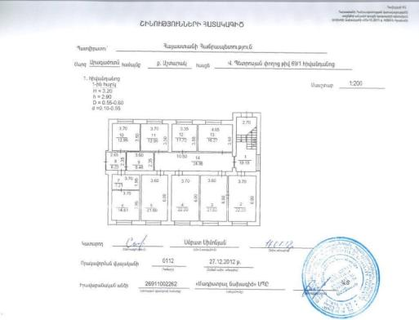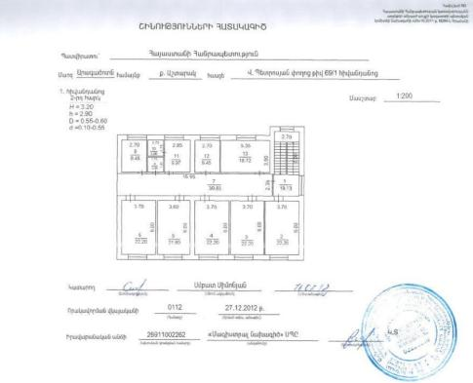

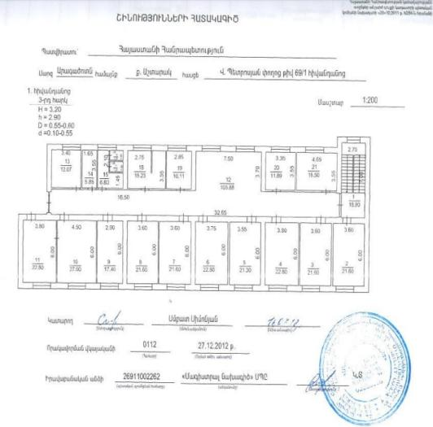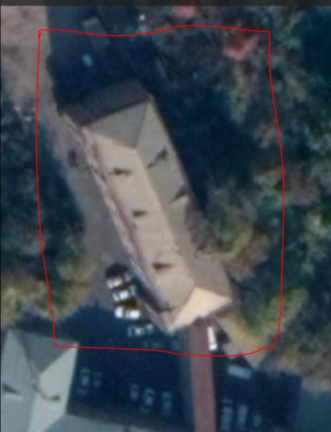

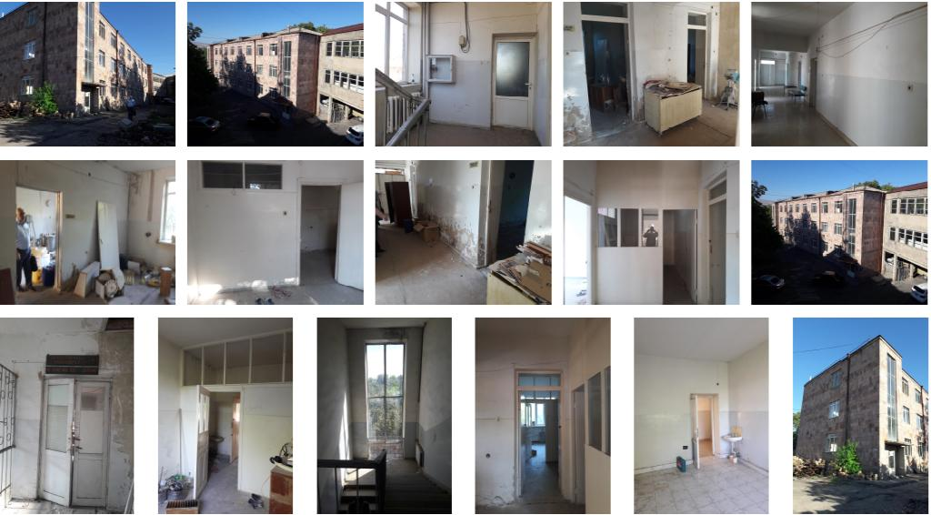

**Attachment 2**

**Premises Ownership Certificate**

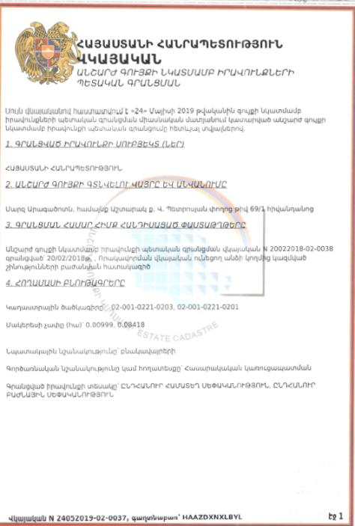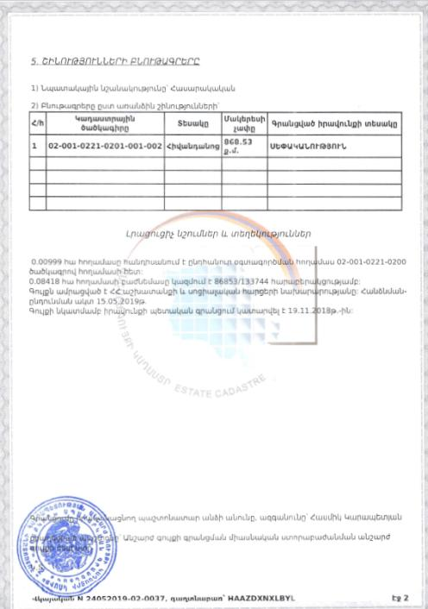

**(Non-official translation)**

**Republic of Armenia**

**Certificate of State Registration of the Rights over**

**Real Estate**

**Cadaster Committee**

This Certificate confirms the state registration of the rights over real estate in the integrated registry of state registration of rights over real estate on May 24, 2019 by the following details:

1. **Entity(s) of registered right**

Republic of Armenia

2. **The place and name of the real estate**

Hospital bld. 69/1 V. Petrosyan str., Ashtarak community, Aragatsotn Marz

**3. Documents on which the registration is based**

Certificate confirming the state registration of the rights over real estate N 20022018-02-0038, registered on 20/02/2018, premises separation plan drawn by a qualified specialist

**4. Land characteristics**

Cadaster Code 02-001-0221-0203, 02-001-0221-0201

Surface – 0.00999, 0.08418 ha

Target use - residential

Operational use – public construction

Type of registered right – Joint ownership, shared ownership

**5. Building characteristics**

1) Target use – public

2) Characteristics of the separate buildings;

|  |  |  |  |  |
| --- | --- | --- | --- | --- |
| N | Cadaster Code | Type | Surface | Type of registered right |
| 1 | 02-001-0221-0201-001-002 | Hospital building | 868.53 sq. m | ownership |

**Additional Notes and Information**

The land plot with an area of 0.00999 ha is in common use with the land plot under 02-001-0221-0200 code.

The share of the land plot with an area of 0.08418 ha is constituted by an 86853/133744 ratio.

The real estate is attached to the RA Ministry of Labor and Social Affairs. Delivery-acceptance act is dated 15.05.2019.

State registration of the right over the real estate was made on 19.11.2018.

Registering official – Hasmik Karapetyan

Position – Real estate register of United Marz subdivision of the State Committee of the Real Estate Cadaster adjunct to the RoA Government.

Certificate N 24052019-02-0037

**Attachment 3. Conclusion on the technical condition of the building**

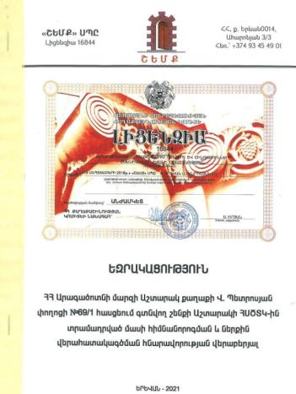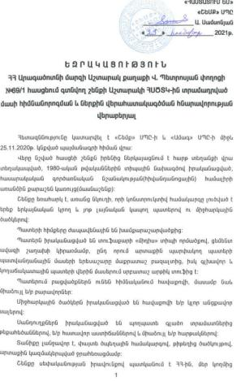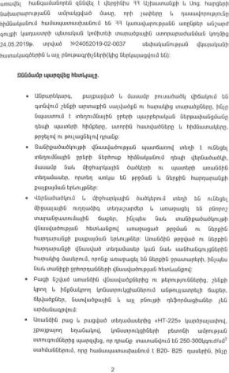

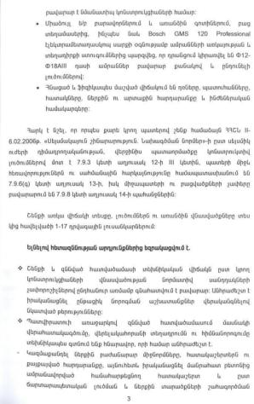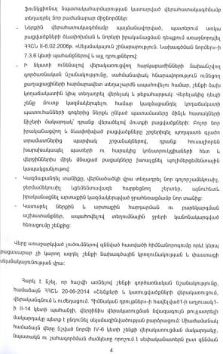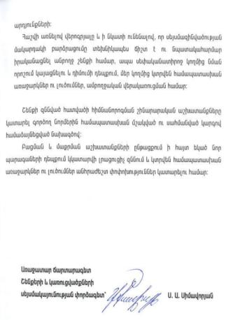

**Summary-Excerpt from the**

**Conclusion on the feasibility of rehabilitation and internal re-planning of the part of the building allocated for the arrangement of the premises for Ashtarak USSTC, located at V. Petrosyan street 69/1, Ashtarak, RA Aragatsotn Marz**

The examination was conducted based upon the Contract signed between “Shemk” LLC (License 16844) and “AMAG” LLC on 25.11.2020.

**Based upon the examination results it is concluded:**

* The technical state of the examined section of the building according to the criteria of the normative scale of damage of the bearing constructions is overall evaluated as satisfactory. It is necessary to implement renovation works to restore the identified defects.
* Based on the Client’s proposal it is technically feasible to implement partial re-planning and overall rehabilitation works, install an elevator shaft. To do so it is necessary to:
* Demolish the inner partition walls, floor layers and dilapidated finishing, then implement concrete reinforced flooring and construct the new partition walls in compliance with the architectural solution and re-planning based upon the functional convenience of the inner space use.
* Make other changes on the walls in compliance with the requirements of paragraphs 7.3.6 and 7.9.3 of “Earthquake-resistant construction; Design norms” of the RoA Construction Norms (II-6.02-2006).
* Considering the operational significance of the rehabilitated floors to ensure the comfortable movement of citizens with disabilities, install an elevator and a wheelchair ramp on the left-wing of the building. Relevant changes will be made to ensure smooth entrance and passage to the building from the elevator.
* Construct a new roof with concrete smoothing layers, organized external water drainage, as well as vapor barrier, heat insulation systems.
* Implement exterior paving with regulated water drainage, modern architectural systems, as well as interior and exterior finishing works and improvement works.

It is recommended to implement the seismic strengthening of the entire building. The exact proposals and solutions will be provided if the Client decides to strengthen the building.

In case of newly arisen circumstances during the opening and cleaning works additional examination will be conducted, relevant recommendations and solutions provided to make the necessary changes.

The reconstruction and renovation works shall be implemented by an agreed design developed in compliance with the existing construction norms.

Leading Specialist,

Seismic resistance expert of

buildings and constructions (signed and sealed) S. Simavoryan

**Attachment 4. Records of Virtual Consultation Meeting**

**MINUTES OF THE VIRTUAL PUBLIC CONSULTATION ON THE DRAFT ESMP**

*Period of public consultation: 24.02.2021 – 05.03.2021*

To prevent the spread of the COVID-19 in Armenia and protect public health, the public consultation activities on the draft ESMP for the establishment of Ashtarak USSTC in the RoA Aragatsotn Marz were carried out online.

The draft Environmental and Social Management Plan (ESMP) for the renovation works of Ashtarak USSTC was publicly disclosed on February 24, 2021, on the official websites of the RoA MLSA and Ashtarak community, and the FB page of the Project to solicit stakeholder feedback and comments (the announcement of public consultation along with the link to the draft ESMP can be found on

<https://www.mlsa.am/?page_id=2631> <https://ashtarak.am/Pages/DocFlow/Default.aspx?a=v&g=a3a863dc-24ab-4986-9019-23d01c2df342>, <https://www.facebook.com/1064730507045063/photos/a.1065189526999161/1892648124253293/>.

Also, an official letter has been sent to the local Heads of Services which will be integrated into the future USSTC, particularly detailing:

1. Major changes in the process of introduction of the Integrated Social Services System in the RoA social protection system;
2. The potential environmental risks and impacts associated with the establishment of Ashtarak USSTC and proposed mitigation and monitoring measures to address the impacts; and
3. The potential social risks and impacts associated with the establishment of Ashtarak USSTC and proposed mitigation and monitoring measures.

**Attachment 5.**

**Waste disposal permit**

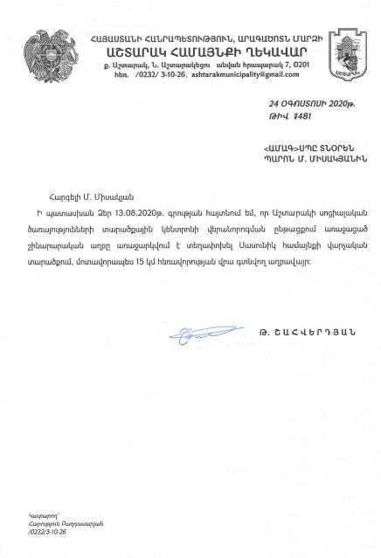

**ARAGATSOTN MARZ OF THE REPUBLIC OF ARMENIA**

**HEAD OF ASHTARAK COMMUNITY**

**7 Square after N. Ashtarakeci, Ashtarak, 0201**

**Tel.: (0232) 3-10-26,**

**E-mail: ashtarakmunicipality@gmail.com**

**N 1481**

**August 24, 2020**

**To: Mr. M. Misakyan**

**“AMAG” LLC Director**

**Dear Mr. Misakyan,**

Replying to your letter, dated 13.08.2020, please be informed that the construction waste generated during the renovation works of the premises of Ashtarak Unified social services territorial center can be transported and disposed of at landfills located about 15 km away from the construction site in the Sasunik community.

Seal/sign T. Shahverdyan

**Attachment 6.**

**Construction Permit**

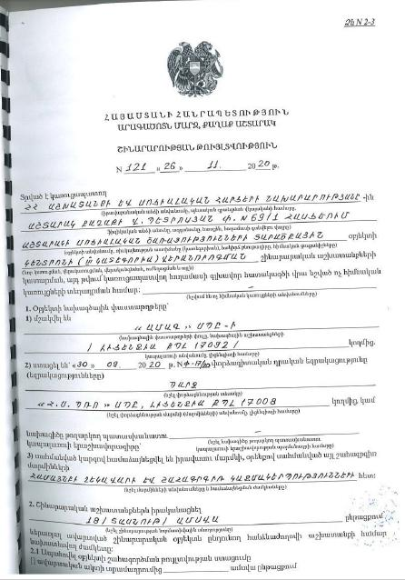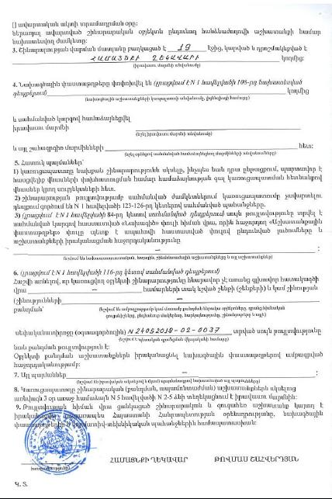

1. Land acquisitions includes displacement of people, change of livelihood encroachment on private property this is to land that is purchased/transferred and affects people who are living and/or squatters and/or operate a business (kiosks) on land that is being acquired.
2. Toxic / hazardous material includes but is not limited to asbestos, toxic paints, noxious solvents, removal of lead paint, etc.