# Annex 14: Checklist Environmental and Social Management Plan

**Armenia Support to Conflict Affected Families Project**

**Checklist Environmental and Social Management Plan**

**PART A: General Project and Site Information**

|  |  |  |  |  |
| --- | --- | --- | --- | --- |
| **INSTITUTIONAL & ADMINISTRATIVE** | | | | |
| Country | Armenia | | | |
| Project title | Armenia Support to Conflict Affected Families Project | | | |
| Scope of site-specific activity | The public works initiated by municipalities will include improvement of public roads, sidewalks, parks, playgrounds, bus stops, bridges, fire water supply, and outdoor lighting, improvement of areas adjacent to historical and cultural monuments, minor renovation of public buildings and surrounding areas, and small scale tree planting and care. These minor works will be implemented in the transformed urban and rural areas, and do not require construction or other permits, and do not involve any hazardous work activity and activity involving toxic materials. | | | |
| Institutional arrangements (WB) | Task Team Leader:  Maddalena Honorati | | Safeguards Specialists:  Environmental: Hmayak Avagyan  Social: Sophia V. Georgieva | |
| Implementation arrangements | Implementing entity:  Ministry of Labor and Social Affairs (MLSA) | Works supervisor:  Safeguards  Tovmas Tadevosyan, Environmental  Nvard Mkrtchyan,  Social | | Works contractor:  Approved Municipality |
| **SITE DESCRIPTION** | | | | |
| Name of institution whose assets are to be rehabilitated | Approved Municipality | | | |
| Description of physical and natural environment, and socio-economic context around the site | The Republic of Armenia is a landlocked mountainous country located in the South Caucasus and bordering Azerbaijan, Georgia, Iran, and Turkey. The majority of the country is at a high altitude (over 1,000m above sea level). The Armenian climate is continental with hot summers and cold winters, and the country is regarded as being especially sensitive to the effects of climate change. The topographic and climatic variations have resulted in highly diverse ecosystems. Armenia is a seismically active country. The country comprises of ten administrative regions, called marzes: Aragatsotn, Ararat, Armavir, Gegharkunik, Kotayk, Lori, Shirak, Syunik, Tavush, and Vayots Dzor. The municipality of the capital city of Yerevan is a self-standing administrative unit. The population of the country slightly exceeds 2.9 million, over 60% of which resides in urban settlements.  The minor works for the renovation of public buildings and the improvement of public infrastructure and spaces will be executed in transformed urban and rural areas. Therefore, the proposed activities cannot affect biodiversity and living natural resources.  The project's physical footprint is not expected to cause any impact on private land, assets, or livelihoods. | | | |
| **LEGISLATION** | | | | |
| National & local legislation & permits that apply to sub-project activity | The following Armenian legislation defines a legal framework applicable to project activities:   * Law on Atmospheric Air Protection of RoA (1994)   The purpose of the Law on Atmospheric Air Protection is to define the main principles of the RoA, directed to the provision of purity of atmospheric air and improvement of air quality, prevention and mitigation of the chemical, physical, biological and other impacts on air quality and regulation of public relation. This Law also regulates the emission licenses and provides maximum allowed loads/concentrations for atmospheric air pollution, etc.  *According to this law, the contractor shall undertake construction activities as well as transportation and temporary storage of waste the way to minimize dust and other emissions.*   * Law on Waste of RoA (2004)   The law provides the legal and economic basis for the collection, transportation, disposal, treatment, re-use of wastes as well as prevention of negative impacts of waste on natural resources, human life and health. The law defines the roles and responsibilities of the state authorized bodies as well as of waste generator organizations in waste management operations  *According to this law, the waste generated from construction activities should be recycled as appropriate or disposed of in designated locations.*  *Disposal of the construction waste and excess material in selected locations must be approved by the local municipality in writing.* | | | |
| **PUBLIC CONSULTATION** | | | | |
| When / where the public consultation process will take /took place | The draft ESMP was disclosed on the website of MLSA and on the SPAP II Facebook page and discussed at the virtual meeting with the participants from involved communities.  Brief information on the planned works and contact information for addressing questions and grievances will be placed on the information boards of the respective municipality and at the worksite or in its immediate surroundings. | | | |
| **ATTACHMENTS** | | | | |
| Attachment 1: Minutes of public consultation on the draft ESMP  Attachment 2: Proposed training plan | | | | |

**PART B: safeguards information**

|  |  |  |  |
| --- | --- | --- | --- |
| **ENVIRONMENTAL /SOCIAL SCREENING** | | | |
| Will the site activity include/involve any of the following? | **Activity/Issue** | **Status** | **Triggered Actions** |
| 1. Minor rehabilitation/renovation works | [√ ] Yes [] No | If “Yes”, See Section **A** below |
| 1. Small-scale new construction | [] Yes [√] No | If “Yes”, See Section **A** below |
| 1. Historic building(s) and districts | [ ] Yes [√] No | If “Yes”, See Section **B** below |
| 1. Acquisition of land[1] | [ ] Yes [√] No | If “Yes”, See Section **C** below |
| 1. Hazardous or toxic materials[2] | [ ] Yes [√] No | If “Yes”, See Section **D** below |
| 1. Traffic and pedestrian safety | [√] Yes [ ] No | If “Yes”, See Section **E** below |
| 1. Social risk management | [√] Yes [ ] No | If “Yes”, See Section **F** below |

**PART C: Mitigation measures**

|  |  |  |
| --- | --- | --- |
| **ACTIVITY** | **PARAMETER** | **MITIGATION MEASURES** |
| **0**. General Conditions | Notification and Worker Safety | 1. The local communities are notified of upcoming activities 2. The public is notified of the works through appropriate notification in the media and/or at publicly accessible sites (including the site of the works) 3. The Municipality formally agrees that all work will be carried out in a safe and disciplined manner designed to minimize impacts on neighboring residents and environment. 4. Workers’ personal protection equipment complies with international good practice (always hardhats, as needed masks and safety glasses, harnesses and safety boots) 5. Appropriate signposting of the sites informs workers of key rules and regulations to follow. |
| 1. General Rehabilitation and /or construction activities | Air Quality | 1. During earth works, dust is suppressed by ongoing water spraying and/or installing dust screen enclosures at site. 2. The surrounding environment (sidewalks, roads) is kept free of debris to minimize dust. 3. There is no open burning of construction / waste material at the site. 4. There is no excessive idling of construction vehicles at sites. |
| Noise | 1. Construction noise is limited to restricted times agreed to in the permit. 2. During operations, the engine covers of generators, air compressors and other powered mechanical equipment are closed, and equipment placed as far away from residential areas as possible. |
| Water Quality | 1. Appropriate erosion and sediment control measures are applied such as e.g. hay bales and / or silt fences to prevent sediment from moving off site and causing excessive turbidity in nearby streams and rivers. 2. Rainwater is removed from the construction site using a rainwater drainage system. |
| Waste Management | 1. Waste collection and disposal pathways and sites are identified for all major waste types expected from demolition and construction activities. 2. Mineral construction and demolition wastes are separated from general refuse, organic, liquid and chemical wastes by on-site sorting and stored in appropriate containers. 3. Construction waste is being collected and disposed properly by licensed collectors. 4. Whenever feasible, appropriate and viable materials (except asbestos) are reused or recycled. |
| 1. Historic building(s) and district(s) |  | * 1. If the building is a designated historic structure, very close to such a structure, or located in a designated historic district, do not commence works without receiving a notice that the design is agreed with the Ministry of Education, Science, Culture and Sport, and all construction activities are planned and carried out in line with local and national legislation.   2. Acquaint personnel with the procedures for handling chance finds. Take all physical activity on hold if a change find is suspected or reported by staff and immediately notify the Employer in writing. Do not resume work until formal notice from the Employer. |
| 1. Land | Land Acquisition | * 1. If expropriation of land was not expected but is required, or if loss of access to income of   legal or illegal users of land was not expected but may occur, designs will be modified to avoid such impacts.   * 1. If such impacts are unavoidable, immediately consult the World Bank’s Task Team Leader. |
| 1. Hazardous and Toxic Materials | Asbestos management | * 1. If asbestos is located on the subproject site, mark it clearly as a hazardous material.   2. When possible, appropriately contain and seal asbestos to minimize exposure.   3. Treat asbestos prior to removal (if removal is necessary) with a wetting agent to minimize   4. asbestos dust.   5. Handle and disposed asbestos using skilled & experienced professionals. If asbestos material is being stored temporarily, securely enclosed it inside closed containments and mark appropriately. Take security measures against unauthorized removal from the site.   6. Do not reuse the removed asbestos. |
| 1. Traffic and Pedestrian Safety | Direct or indirect hazards to public traffic and pedestrians by construction  activities | (a) In compliance with national regulations the municipality will ensure that the construction site is properly secured and construction-related traffic regulated. This includes but is not limited to   * + Signpost, place warning signs, arrange barriers and traffic diversions so that the work site is clearly visible, and the public is warned of all potential hazards.   + Establish a traffic management system and conduct staff training, especially for site access and near-site heavy traffic. Provide safe passages and crossings for pedestrians where construction traffic interferes.   + Adjust working hours to local traffic patterns, e.g. avoid major transport activities during rush hours or times of livestock movement.   + Actively manage traffic if required for safe and convenient passage for the public.   + Ensure safe and continuous access to office facilities, shops and residences during renovation activities, if the buildings stay open for the public. |
| 1. Social risk management | Public relationship management | 1. Assign local liaison person in charge of communication with and receiving requests/ complaints from local population. Ensure that grievance focal points are trained on the structure of project GM including SEA/SH protocol. 2. Consult local communities to identify and proactively manage potential conflicts between an external workforce and local people. 3. Raise local community awareness about transmittable disease risks associated with the presence of an external workforce and include local communities in awareness activities, especially COVID-19 safety measures. 4. Inform population about construction and work schedules, interruption of the services, traffic detour routes and provisional bus routes, as appropriate. 5. Limit construction activities at night. When necessary, carefully schedule night-time works and inform affected community so they can take necessary measures. 6. At least five days in advance of any service interruption (including water, electricity, telephone, bus routes), advise the affected community through postings at the project site, at bus stops, and in affected homes/businesses. 7. Address concerns raised through the Grievance Mechanism within the designated timeline. 8. No temporary storage of construction materials and waste occurs within cultivated land   plots or any type of private property   1. Allocate areas for the temporary storage of construction materials and waste so that free movement of traffic and pedestrians is not hindered. |
| Labor management | 1. Provide worker skills training and OHS training. 2. Provide adequate lavatory facilities (toilets and washing areas) in the work site with adequate supplies of hot and cold running water, soap, and hand drying devices. 3. Raise awareness of workers on overall relationship management with local population, establish the code of conduct in line with international practice and strictly enforce them, including the dismissal of workers and financial penalties of adequate scale. 4. Provide workers with information on the employee grievance mechanism. |

**PART D: Monitoring Plan**

|  |  |  |  |  |  |  |
| --- | --- | --- | --- | --- | --- | --- |
| **Activity** | **What**  (Is the parameter to be monitored?) | **Where**  (Is the parameter to be monitored?) | **How**  (Is the parameter to be monitored?) | **When**  (Define the frequency / or continuous?) | **Why**  (Is the parameter being monitored?) | **Who**  (Is responsible for monitoring?) |
| **CONSTRUCTION PHASE** | | | | | | |
| Supply of construction material | Purchase of construction materials from licensed suppliers. | Offices or warehouses of material suppliers. | Verification of  documents | During conclusion of supply contracts | Ensure reliability of construction materials and their safety for human health. | MLSA  USS |
| Transportation of construction materials and waste  Movement of construction  machinery | * Technical condition of vehicles and machinery; * Confinement and protection of truckloads with lining; * Respect of the pre-defined hours and routes of transportation. | * Construction site; * Routes of transportation of construction materials and wastes. | Inspection of roads adjacent to the  construction object in the direction of  the movement route | Undeclared inspection during work hours and beyond | -Limit pollution of soil and air from emissions;  -Limit nuisance to local community from the dust and noise;  -Minimize traffic disruption. | MLSA  USS  Traffic Police |
| Maintenance of  construction equipment | * Washing of cars and construction equipment outside the construction site or at maximum distance from natural streams; * Refueling or lubrication of construction equipment outside the construction site or at the predetermined confined area | Construction site | Inspection of activities | Undeclared inspections during work hours | -Avoid pollution of  water and soil with  oil products due to  operation of  equipment  -Timely localize and  decrease expected  damage | MLSA  USS |
| Generation of construction waste | * Temporary storage of construction waste at the allocated areas; * Timely disposal of construction waste to the formally designated locations. | Construction site;  Waste disposal site | Inspection of activities | Undeclared inspections during work hours | -Prevent pollution of soil, surface water and groundwater,  -Avoid accidents at the construction site due to scattered fragments of construction materials and debris,  - Retain esthetic appearance of the construction site and its surroundings. | MLSA  USS |
| Accumulation of household waste | * Placing waste bins in the activity area; * Timely disposal of waste to the formally designated dumpsite. | Construction site | Inspection of activities | Undeclared inspection during work hours | Avoid pollution by household waste. | MLSA  USS |
| Works in the areas adjacent to historical and cultural monuments | * Exclusion of any activity near monuments listed among cultural and historic structures of the Republic of Armenia that requires a permit. | Construction site | Inspection of activities and site | Entire period of  construction | Prevent the impacts on  historical and cultural monuments. | MLSA  USS |
| Construction site reinstatement and landscaping | Final cleaning of the construction site and permanent access roads and landscaping-greening of the area as required. | Construction site and access routes | Inspection of construction site | Site reinstatement phase/period | Reduce loss of aesthetical value of the landscape due to construction activities | MLSA  USS |
| Workers’ health and safety | * Providing workers with working clothes and PPE; * Strict compliance with the rules of construction equipment operation and usage of PPE; * Presence of basic fire extinguishing and first aid kits means; * Availability of labor safety training and instruction records. | Workplace | Inspection of activities  Inspection of documents | Entire period of  construction | Reduce the probability of accidents | MLSA  USS |
| COVID-19 preparedness in the work site | * Provision of hand wash facilities in the worksite with adequate supplies of running water, hand soap, alcohol-based hand sanitizer and hand drying devices; * Worksite entrance procedure and medical checks; * Regular disinfection of public rooms, equipment, tools; * Work practices to reduce or minimize contact between workers; * Provision of face masks and other relevant PPE to all project workers at the entrance to the project site. | Workplace | Inspection of activities | Entire period of  works | Prevent COVID-19 infection risk at worksites | MLSA  USS |
| Traffic and road safety | * Signposting, warning signs, barriers and traffic diversions: construction site visible and the public warned of all potential hazards; * Traffic management by trained and visible staff at the site for safe passage for the public; * Provision of safe passages and crossings for pedestrians where construction traffic interferes; * Adjustment of working hours to local traffic patterns to avoid major transport activities during rush hours; * Safe and continuous access to nearby office facilities, shops and residences during construction works. | Construction site and access routes | Inspection of activities | Entire period of works | - Minimize direct or indirect hazards to public traffic and pedestrians by construction activities;  - Minimize traffic disruption. | MLSA  USS  Traffic Police |
| Grievance mechanism (GM) | * GM contact information visibly displayed on all work sites * Grievances recorded and addressed within prescribed timeline. | Construction site and other public areas within the communities where project activities take place | Inspection of activities | Entire period of works | Ensure accessible means of grievance and redress for all citizens who may be affected | MLSA  USS  Municipality |
| **OPERATION PHASE** | | | | | | |
| Maintenance of public building | * Power lines, water/sewage pipelines maintained and in good operating condition | Public building | Periodic check-ups | Total period of operation | Exclude risks of electric shocks, short circuits, and leakage of pipes | Administration of public building |
| Exploitation and maintenance of road | * Cleaning road surface from litter deposited out of moving vehicles; * Timely confinement, deactivation, and removal of liquid or powder spills of cargo in case of road accidents; * Collection and timely disposal of waste from road maintenance works to a designated landfill. | Carriageway of the road | Visual inspection | -As required in response to an accident;  - Regular, to be determined by local municipality | - Ensure the safety of traffic and prevent environmental pollution;  - Ensure the aesthetic appearance of the road | Municipality |

**Attachment 1**

**MINUTES OF THE PUBLIC CONSULTATION MEETING ON THE DRAFT**

**ENVIRONMENTAL AND SOCIAL MANAGEMENT PLAN FOR PUBLIC WORKS**

Date 01.07.2021

Meeting duration: 11:00 – 11:45

After the official publication ([**http://www.mlsa.am**](https://www.mlsa.am/?page_id=2631), 24.06.2021) of the Armenian and English language announcement regarding the public consultation on the draft Environmental and Social Management Plan for implementation of public works supported by “SPF: Armenia Support to Conflict Affected Families” project, a public consultation meeting was held via Zoom communication platform with the purpose of raising awareness among stakeholders by the Social Affairs and Project Coordination Unit (PCU) of the joint Social Protection Administration II Project (SPAP II) of the RA Ministry of Labor and Social Affairs and the World Bank. 6 stakeholders actively participated in the public consultation meeting.

Prior to the public consultation meeting, the draft ESMP has been disseminated among the key stakeholders via email. Overall, 18 organizations received a copy of the draft ESMP with a request to review and provide their feedback and suggestions on the document. The stakeholders did not raise any special questions regarding the draft ESMP. The list of recipients is attached to the summary of the public consultation.

**AGENDA**

**of Public Consultation Meeting**

1. Introduction of “Armenia Support to Conflict Affected Families” Project. Speaker – Nvard Mkrtchyan, SPAP II ME & Social Safeguards Specialist.
2. Introduction of Environmental section of Project’s **Environmental and Social Management Plan**. Speaker – Tovmas Tadevosyan, SPAP II Environmental Specialist.
3. Introduction of Social section of Project’s **Environmental and Social Management Plan**. Speaker – Nvard Mkrtchyan, SPAP II ME & Social Safeguards Specialist.
4. Questions and answers.

**Summary of the public consultation**

Nvard Mkrtchyan, SPAP II ME & Social Safeguards Specialist, introduced the Project development objective, main activities which will be implemented under the Project and expected outcomes. Project’s Environmental and Social Management Plan: main sections; social section.

Tovmas Tadevosyan, SPAP II Environmental Specialist, Introduced the Environmental section of the Project’s Environmental and Social Management Plan.

Meeting participants were given the floor for questions and comments.

**Question 1:** Valeri Jaghinyan - Head of the Social Security Division of the Healthcare and Social Security Department of Lori provincial administration

Will COVID-19 awareness-raising activities be implemented?

**Answer** – Nvard Mkrtchyan

The employees responsible for implementing the public works will be provided with COVID-19 safety awareness raising training.

**Question 2**: Arevik Stepanyan – Chief Specialist of the Employment Programs Coordination Division of the Employment Provision and Labor Potential Development Department

How many beneficiaries will be included in the Public works?

**Answer** – Nvard Mkrtchyan

The project aims to reach approximately 115 displaced people through the public works program.

**List of participants**

|  |  |  |  |  |
| --- | --- | --- | --- | --- |
| N | **Name** | **Institution** | **Position** | **E-mail/Telephone** |
| 1. | Valeri Jaghinyan | Lori provincial administration | Head of the Social Security Division of the Healthcare and Social Security Department | [jva_1960@mail.ru](mailto:jva_1960@mail.ru)  +374 322 2 33 99 |
| 2. | Arevik Stepanyan | USS | Chief Specialist of the Employment Programs Coordination Division of the Employment Provision and Labor Potential Development Department | [arevik.stepanyan@socservice.am](mailto:arevik.stepanyan@socservice.am)  +374 60 65 27 12 |
| 3. | Gohar Varagyan | USS | Head of Social Work և Employment Service of Artik USSTC | [gohar.varagyan@socservice.am](mailto:gohar.varagyan@socservice.am)  +374 55 45 22 13 |
| 4. | Jemma Simonyan | USS | Head of the Programs of Ashtarak USSTC | [Jem57@mail.ru](mailto:Jem57@mail.ru)  +374 93 49 14 73 |
| 5. | Marieta Nikoyan |  | Beneficiary |  |
| 6. | Arus Tumanyan |  | Beneficiary |  |

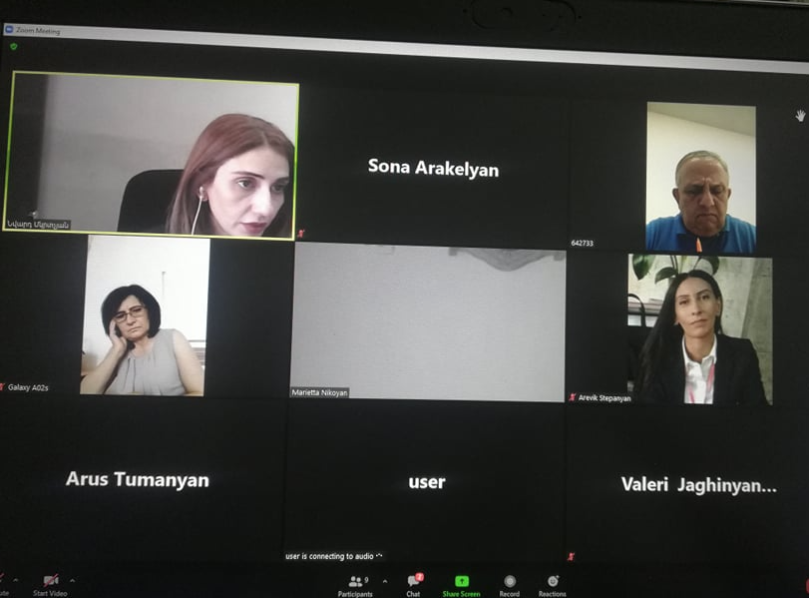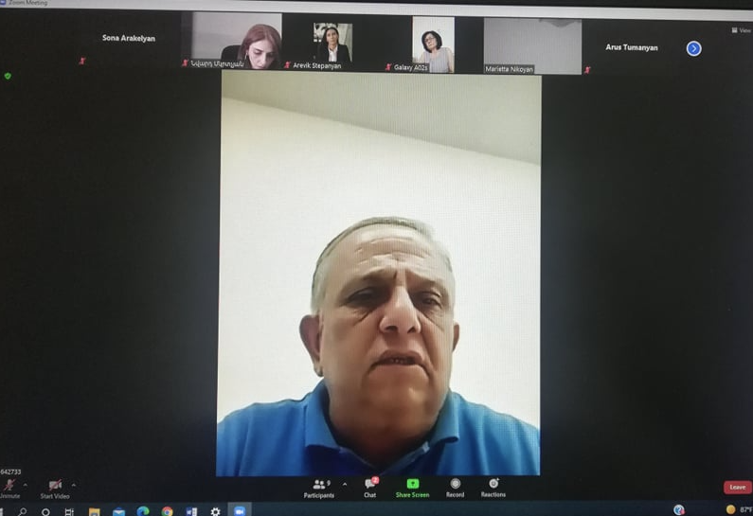

**The List of the Stakeholders and other Interested Parties who received a copy of the draft ESMP via emailing**

|  |  |  |  |
| --- | --- | --- | --- |
| **N** | **Institution** | **Telephone** | **E-mail** |
|  | World Vision | (+374 10) 74 91 18  (+ 37460) 74 91 19 | [wvarmenia@wvi.org](mailto:wvarmenia@wvi.org) |
|  | Armenian Caritas | (+374 312) 5 72 01 | [info@caritas.am](mailto:info@caritas.am)  [caritas@caritasarmenia.org](mailto:caritas@caritasarmenia.org) |
|  | People in Need | (+374-60) 51-91-59 | [info.armenia@peopleinneed.cz](mailto:info.armenia@peopleinneed.cz) |
|  | Mission Armenia | (+37410) 44-47-92 | [org@ngo.mission.am](mailto:org@ngo.mission.am) |
|  | Armenian Red Cross Society | (+374 60) 62 50 50 | [redcross@redcross.am](mailto:redcross@redcross.am) |
|  | “Association for Sustainable Human Development” NGO | (+374 10) 52 23 27 | [karined@web.am](mailto:karined@web.am) |
|  | “Greens Union of Armenia” NGO | (+374 93) 08 11 70 | [armgreen@ipia.sci.am](mailto:armgreen@ipia.sci.am) |
|  | “Association of young biologists” NGO | (+374 99) 23 86 86 | [info@yba.am](mailto:info@yba.am) |
|  | Social Security Division of the Healthcare and Social Security Department of Aragatsotn Marz administration | (+374 232) 3 32 50 | [aragatsotn.aroghj@mta.gov.am](mailto:aragatsotn.aroghj@mta.gov.am) |
|  | Social Security Division of the Healthcare and Social Security Department of Ararat Marz administration | (+374 235)  2 23 16 | [ararat.aroghj@mta.gov.am](mailto:ararat.aroghj@mta.gov.am) |
|  | Social Security Division of the Healthcare and Social Security Department of Gegharkunik Marz administration | (+374 60) 65 06 23 | [gegharquniq.social@mta.gov.am](mailto:gegharquniq.social@mta.gov.am) |
|  | Social Security Division of the Healthcare and Social Security Department of Lori Marz administration | (+ 374 322) 2 33 99 | [jva_1960@mail.ru](mailto:jva_1960@mail.ru) |
|  | Social Security Division of the Healthcare and Social Security Department of Syunik Marz administration | (+374 285) 4 42 95 | [syunik.sots@mtaes.am](mailto:syunik.sots@mtaes.am) |
|  | Social Security Division of the Healthcare and Social Security Department of Vayots Dzor Marz administration | (+374281) 2 40 69 | [vayotsdzor.social@mta.gov.am](mailto:vayotsdzor.social@mta.gov.am)  [vayotsdzor.aroghj@mta.gov.am](mailto:vayotsdzor.aroghj@mta.gov.am) |
|  | Social Security Division of the Healthcare and Social Security Department of Tavush Marz administration | (+374 263) 4 22 40 | [tavush.aroghj@mta.gov.am](mailto:tavush.aroghj@mta.gov.am) |
|  | Employment Programs Coordination Division of the Employment Provision and Labor Potential Development Department | (+374 60) 65 27 12 | [arevik.stepanyan@socservice.am](mailto:arevik.stepanyan@socservice.am) |
|  | Social Work և Employment Service of Artik USSTC | (+374 55) 45 22 13 | [gohar.varagyan@socservice.am](mailto:gohar.varagyan@socservice.am) |
|  | Ashtarak USSTC | (+374 93) 49 14 73 | [յem57@mail.ru](mailto:յem57@mail.ru) |

**Attachment 2**

**Proposed training plan**

**Training for Municipalities and USS Territorial Centres employees responsible for implementing public works**

In the frame of “SPF: Armenia Support to Conflict Affected Families” Project it is planned to deliver training on application and monitoring of ESMP checklist; Labor Management Procedures and GRM for workers; Occupational health and safety, including emergency prevention and preparedness and response arrangements to emergency situations; COVID-19 infection safety awareness, community health and safety, including HIV awareness, and SEA/SH. The training will be delivered by Project’s Environmental and Social specialists by visiting relevant communities and USS Territorial Centers to the employees responsible for implementing public works. The training is planned for the period of August 15-30, 2021, with the employees from each municipality and USS Territorial Center.

The training schedule is presented below.

|  |  |  |  |  |
| --- | --- | --- | --- | --- |
| N | Topic | Organization | Proposed number of participants | Proposed date |
| 1. | Training on application and monitoring of ESMP checklist | Municipalities and USS Territorial Centers employees | 40 (Municipality - 20; USS Territorial Centers – 20 employees) | August 15-30, 2021 |
| 2. | Labor Management Procedures and GRM for workers |
| 3. | Occupational health and safety, including emergency prevention and preparedness and response arrangements to emergency situations |
| 4. | COVID-19 infection safety awareness, community health and safety, including HIV awareness, and SEA/SH |

1. Land acquisitions includes displacement of people, change of livelihood encroachment on private property this is to land that is purchased/transferred and

   affects people who are living and/or squatters and/or operate a business (kiosks) on land that is being acquired.
2. Toxic / hazardous material includes but is not limited to asbestos, toxic paints, noxious solvents, removal of lead paint, etc.